**Assignment – C# (Banking System)**

1)

using System;

namespace Task1

{

class Program

{

static void Main(string[] args)

{

int c, income;

Console.WriteLine("Enter the Credit Score and Income:");

c=Convert.ToInt32(Console.ReadLine());

income=Convert.ToInt32(Console.ReadLine());

if (c>700 && income<50000)

{

Console.WriteLine("You are eligible for loan.");

}

else

{

Console.WriteLine("You are not eligible for loan.");

}

}

}

}

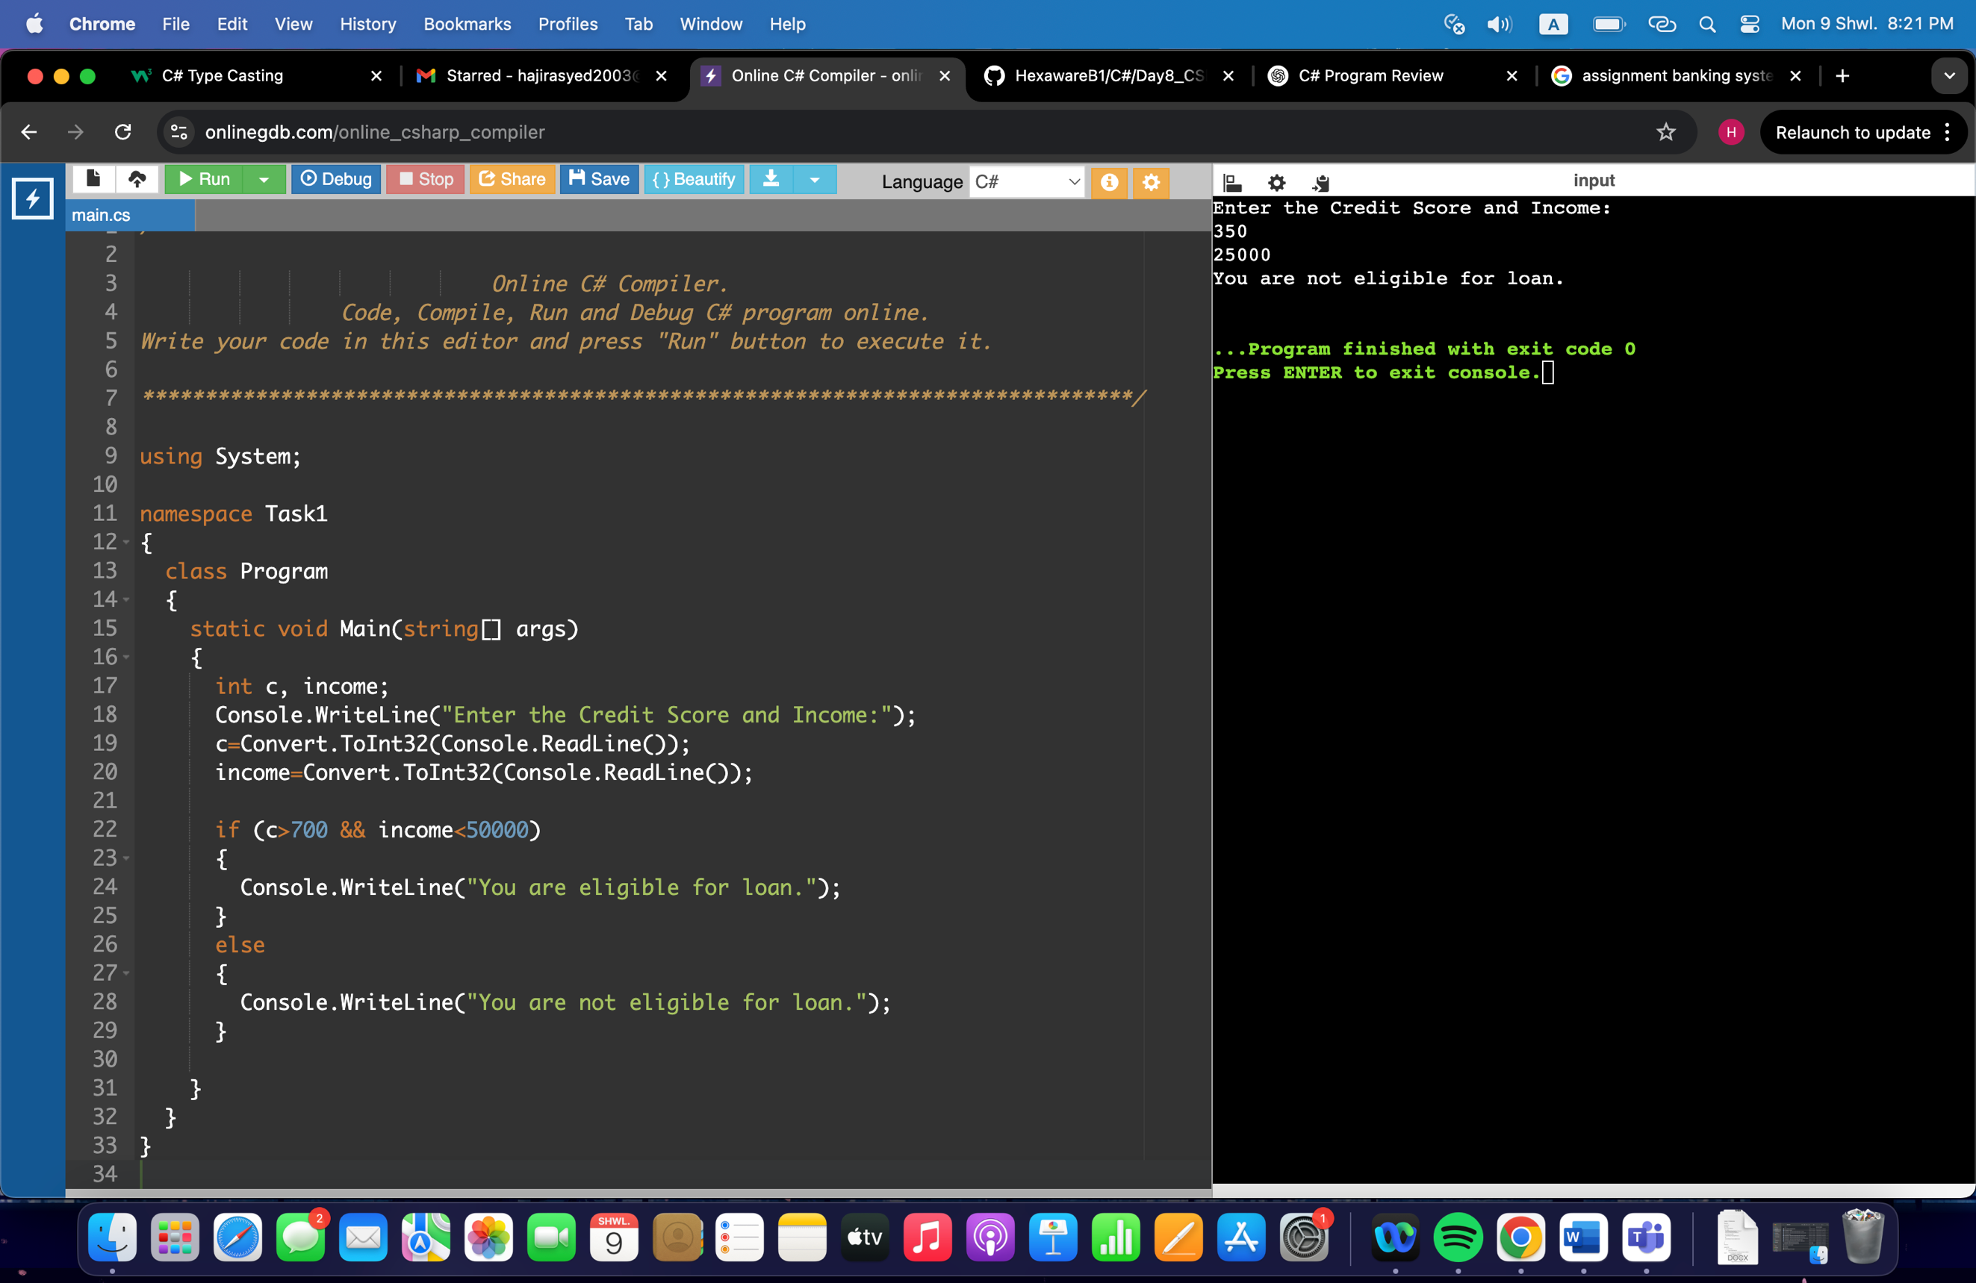

2)

using System;

namespace Task2

{

public class Program

{

static void Main(string[] args)

{

Console.WriteLine("Enter Current Balance and Amount to withdraw or deposit");

Console.WriteLine("1. Check Balance");

Console.WriteLine("2. Withdraw");

Console.WriteLine("3. Deposit");

Console.WriteLine("Choose one of the options");

int bal=Convert.ToInt32(Console.ReadLine());

int amt=Convert.ToInt32(Console.ReadLine());

int opt=Convert.ToInt32(Console.ReadLine());

switch(opt)

{

case 1:

Console.WriteLine("The current balance is:"+ bal);

break;

case 2:

if (bal>amt)

{

if (amt%500==0 || amt%100==0)

{

Console.WriteLine("Amount Withdrawal Success!");

}

else

{

Console.WriteLine("Amount must be in multiples of 100 or 500");

}

}

else

{

Console.WriteLine("Insufficient Balance. Withdrawal Failure.");

}

break;

case 3:

Console.WriteLine("Successfully Deposited.");

break;

default:

Console.WriteLine("Incorrect Option. Exited");

break;

}

}

}

}

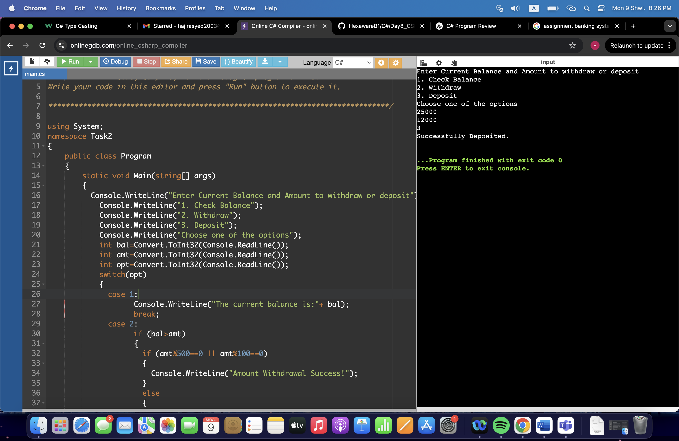

3)

using System;

namespace Task3

{

class Program

{

static void Main(string[] args)

{

Console.WriteLine("Enter the number of Savings Account");

int n=Convert.ToInt32(Console.ReadLine());

for (int i=0; i<n; i++)

{

Console.WriteLine("Enter Initial Balance, Rate of Interest and Number of Years");

double bal=Convert.ToDouble(Console.ReadLine());

double r=Convert.ToDouble(Console.ReadLine());

double y=Convert.ToDouble(Console.ReadLine());

double f_bal= bal * Math.Pow((1+r/100),y);

Console.WriteLine("The future balance is:"+f_bal);

}

}

}

}

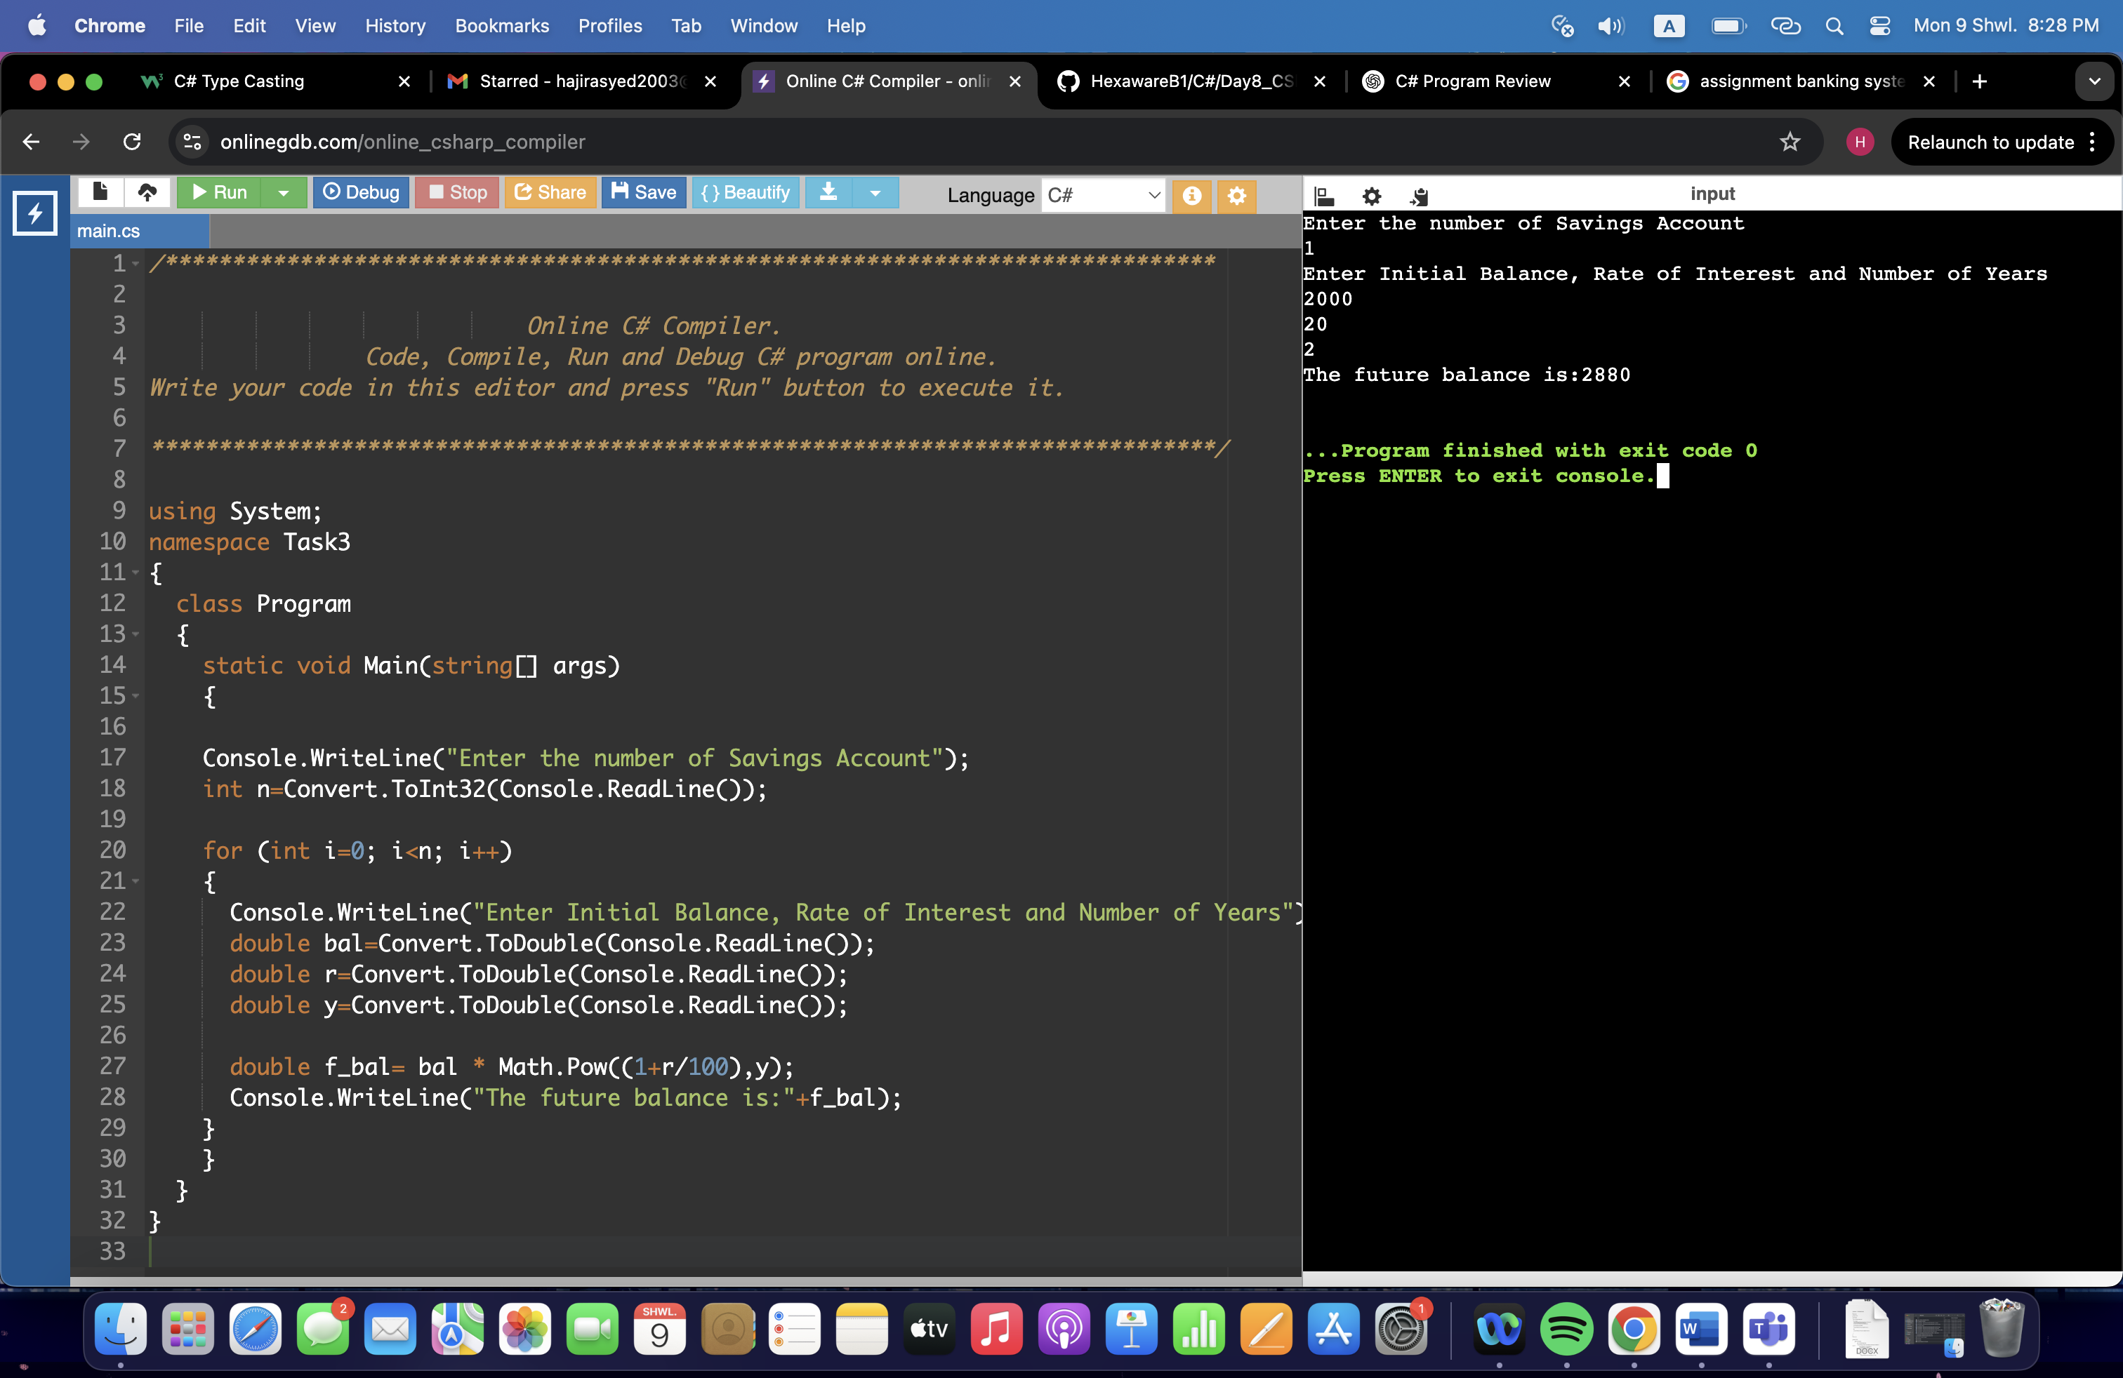

4)

using System;

namespace Task4

{

class Program

{

static void Main(string[] args)

{

string[] account={"15121", "15122", "15123", "15124", "15136"};

bool valid=false;

while(!valid)

{

Console.WriteLine("Enter the account number and balance");

string acc=(Console.ReadLine());

double balance=Convert.ToDouble(Console.ReadLine());

foreach(string i in account)

{

if (acc==i)

{

valid=true;

Console.WriteLine("Account Balance:"+balance);

break;

}

else

{

valid=false;

}

}

}

}

}

}

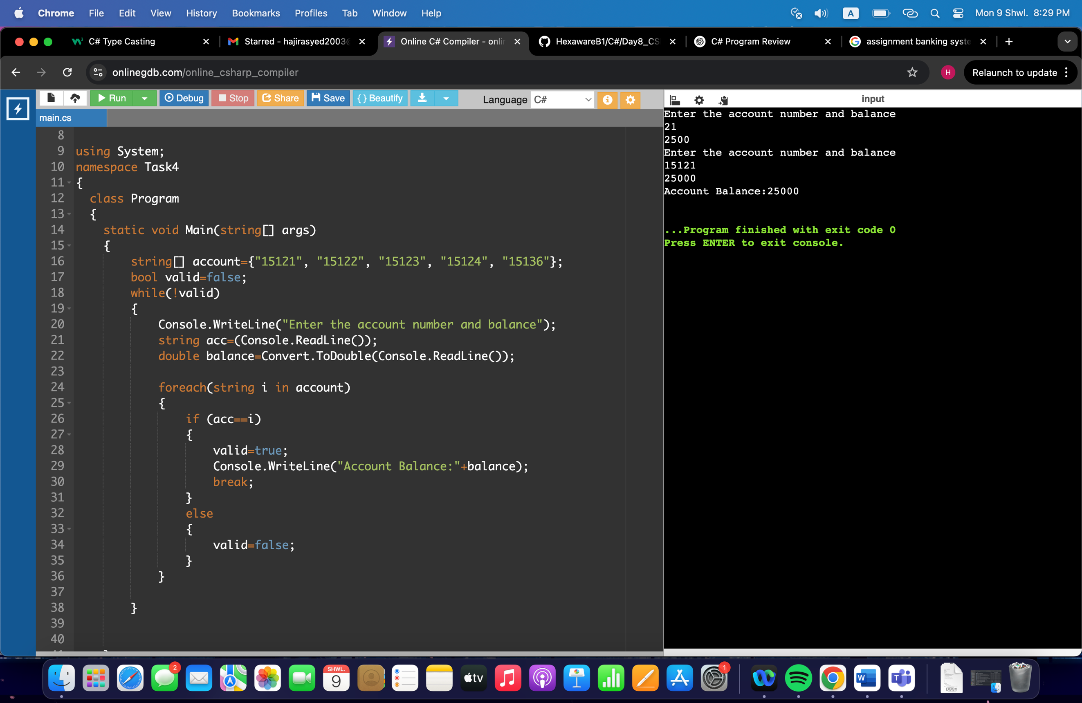

5)

using System;

namespace Task5

{

class program

{

static void Main(string[] args)

{

Console.WriteLine("Create a password:");

string password=Console.ReadLine();

int l=password.Length;

if (l<8)

{

Console.WriteLine("Create a password with atleast 8 charaters.");

}

bool val=false;

foreach(char i in password)

{

if (Char.IsUpper(i))

{

val=true;

break;

}

}

if (!val)

{

Console.WriteLine("The password must contain atleast 1 uppercase character.");

}

bool val2=false;

foreach(char i in password)

{

if (Char.IsDigit(i))

{

val2=true;

break;

}

}

if (!val2)

{

Console.WriteLine("The password must contain atleast 1 digit.");

}

if (l>=8 && (val && val2))

{

Console.WriteLine("Password accepted");

}

}

}

}

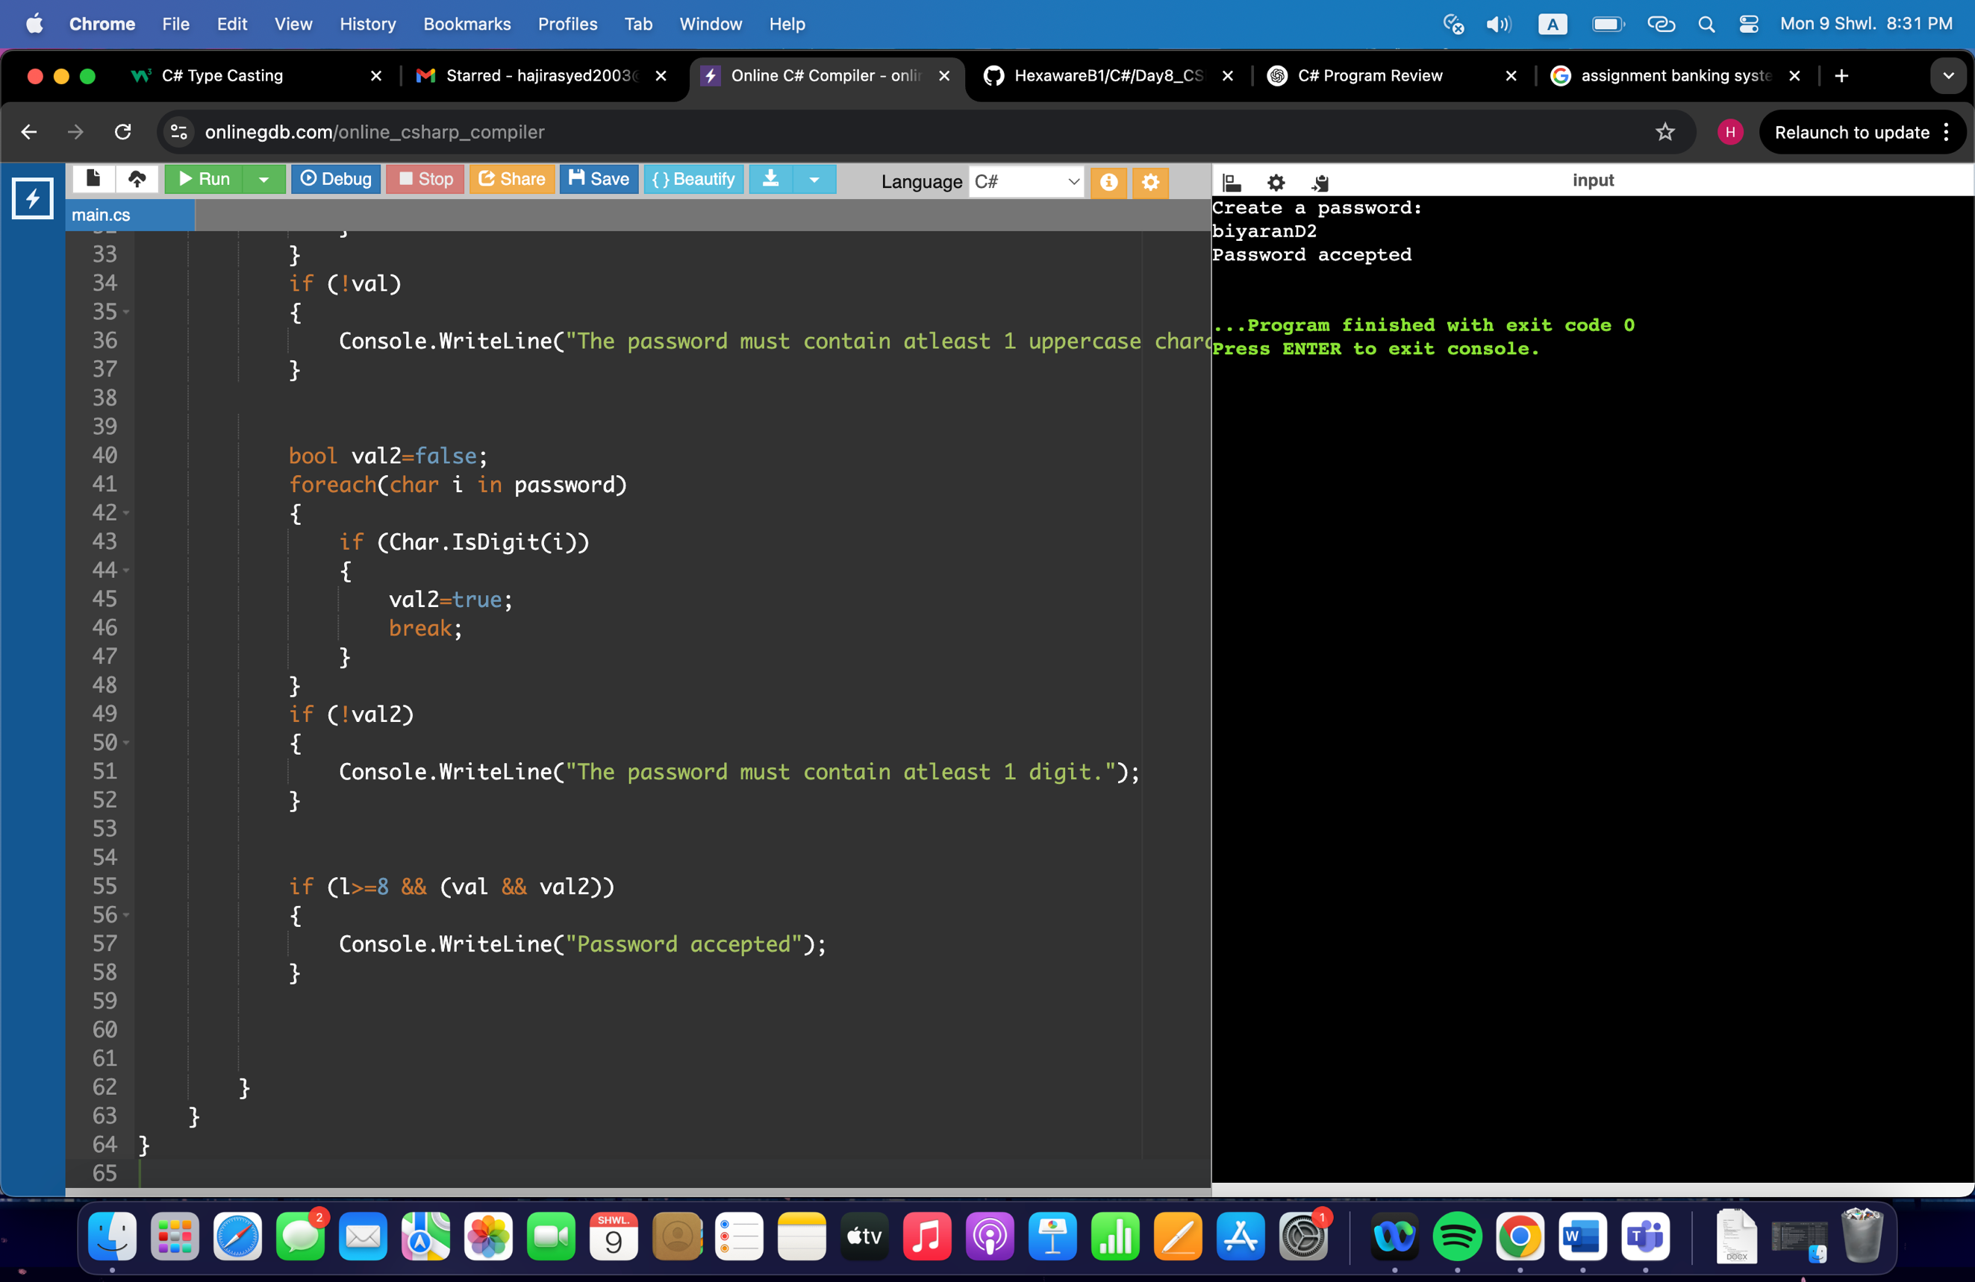

6)

using System;

namespace Task6

{

class program

{

static void Main(string[] args)

{

string[] history=new string[20];

double balance;

Console.WriteLine("Enter balance:");

balance=Convert.ToDouble(Console.ReadLine());

bool valid=true;

int index=0;

do{

Console.WriteLine("1. Withdrawal");

Console.WriteLine("2. Deposit");

Console.WriteLine("3. Exit");

Console.WriteLine("Enter options 1 or 2 or 3");

int opt=Convert.ToInt32(Console.ReadLine());

switch(opt)

{

case 1:

Console.WriteLine("Enter the amount to withdraw:");

double amount=Convert.ToDouble(Console.ReadLine());

if (amount>balance)

{

Console.WriteLine("Insufficient Funds");

}

else

{

balance-=amount;

history[index++]=$"Withdrawn Amount: {amount}";

}

break;

case 2:

Console.WriteLine("Enter the amount to be deposited:");

double amount2=Convert.ToDouble(Console.ReadLine());

balance+=amount2;

history[index++]=$"Deposited Amount: {amount2}";

break;

case 3:

valid=false;

Console.WriteLine("Balance Amount:"+balance);

foreach(string i in history)

{

Console.WriteLine(i);

}

break;

}

}while(valid);

}

}

}

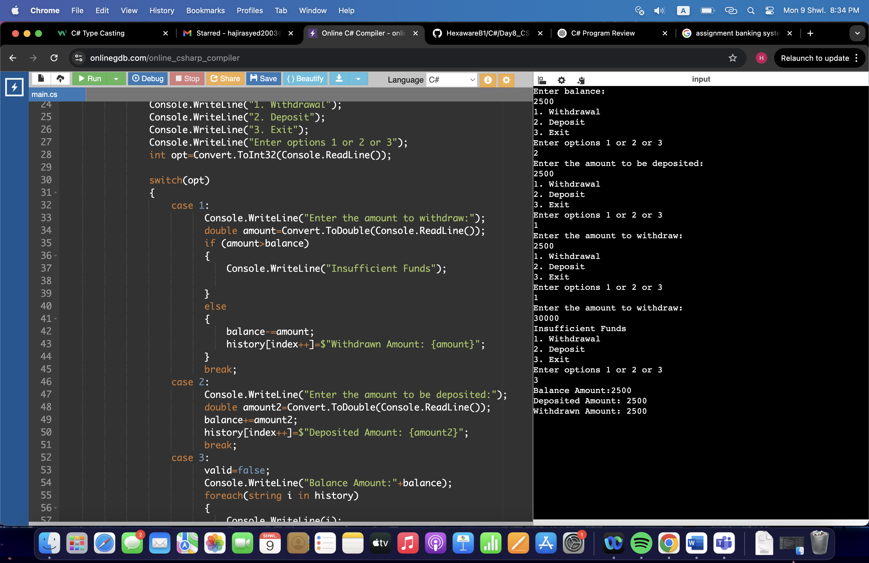

7) 1)

using System;

namespace Task7

{

class Customer

{

private int customerId;

private string firstname;

private string lastname;

private string email;

private int phone;

private string address;

public Customer()

{

customerId=0;

firstname="none";

lastname="none";

email="none";

phone=0;

address="none";

}

public Customer(int id, string f, string l, string e, int num, string a)

{

customerId=id;

firstname=f;

lastname=l;

email=e;

phone=num;

address=a;

}

public int CustomerId

{

get { return customerId; }

set { customerId = value; }

}

public string Firstname

{

get { return firstname;}

set {firstname=value;}

}

public string Lastname

{

get {return lastname;}

set {lastname=value;}

}

public string Email

{

get {return email;}

set {email=value;}

}

public int Phone

{

get {return phone;}

set {phone=value;}

}

public string Address

{

get {return address;}

set {address=value;}

}

public void Printinfo()

{

Console.WriteLine("CustomerId :"+customerId);

Console.WriteLine("First Name: " + firstname);

Console.WriteLine("Last Name: " + lastname);

Console.WriteLine("Email Address: " + email);

Console.WriteLine("Phone Number: " + phone);

Console.WriteLine("Address: " + address);

}

}

class Program

{

static void Main(string[] args)

{

Customer obj=new Customer();

obj.CustomerId=21;

obj.Printinfo();

}

}

}

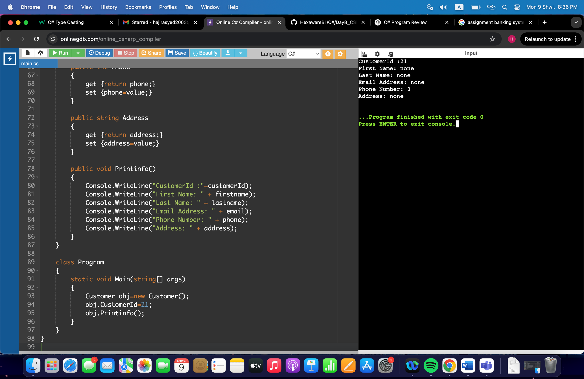

7) 2)

using System;

namespace Task7

{

class Account

{

private int accnum;

private string acctype;

private double balance;

public Account()

{

accnum=0;

acctype="savings";

balance=0;

}

public Account(int a, string t, double b)

{

accnum=a;

acctype=t;

balance=b;

}

public int Accnum

{

get { return accnum;}

set {accnum=value;}

}

public string Acctype

{

get { return acctype; }

set {acctype=value; }

}

public double Balance

{

get { return balance;}

set {balance=value;}

}

public void PrintInfo()

{

Console.WriteLine("Account Number :"+ accnum);

Console.WriteLine("Account Type:"+ acctype);

Console.WriteLine("Account Balance:"+ balance);

}

public void Deposit(double amt)

{

balance+=amt;

Console.WriteLine("Amount has been successfully deposited!");

}

public void Withdraw(double amt)

{

if (amt>balance)

{

Console.WriteLine("Insufficient Funds");

}

else

{

balance-=amt;

Console.WriteLine("Amount has successfully been withdrawn");

}

}

public void Interest(int t)

{

double si = (balance*t*4.5)/100;

Console.WriteLine("The interest on the Balance is:"+si);

}

}

class Bank

{

static void Main(string[] args)

{

Account obj=new Account(23, "savings", 25000.00);

obj.PrintInfo();

obj.Deposit(15000.00);

obj.Withdraw(10000.00);

if (obj.Acctype=="savings")

{

obj.Interest(1);

}

}

}

}

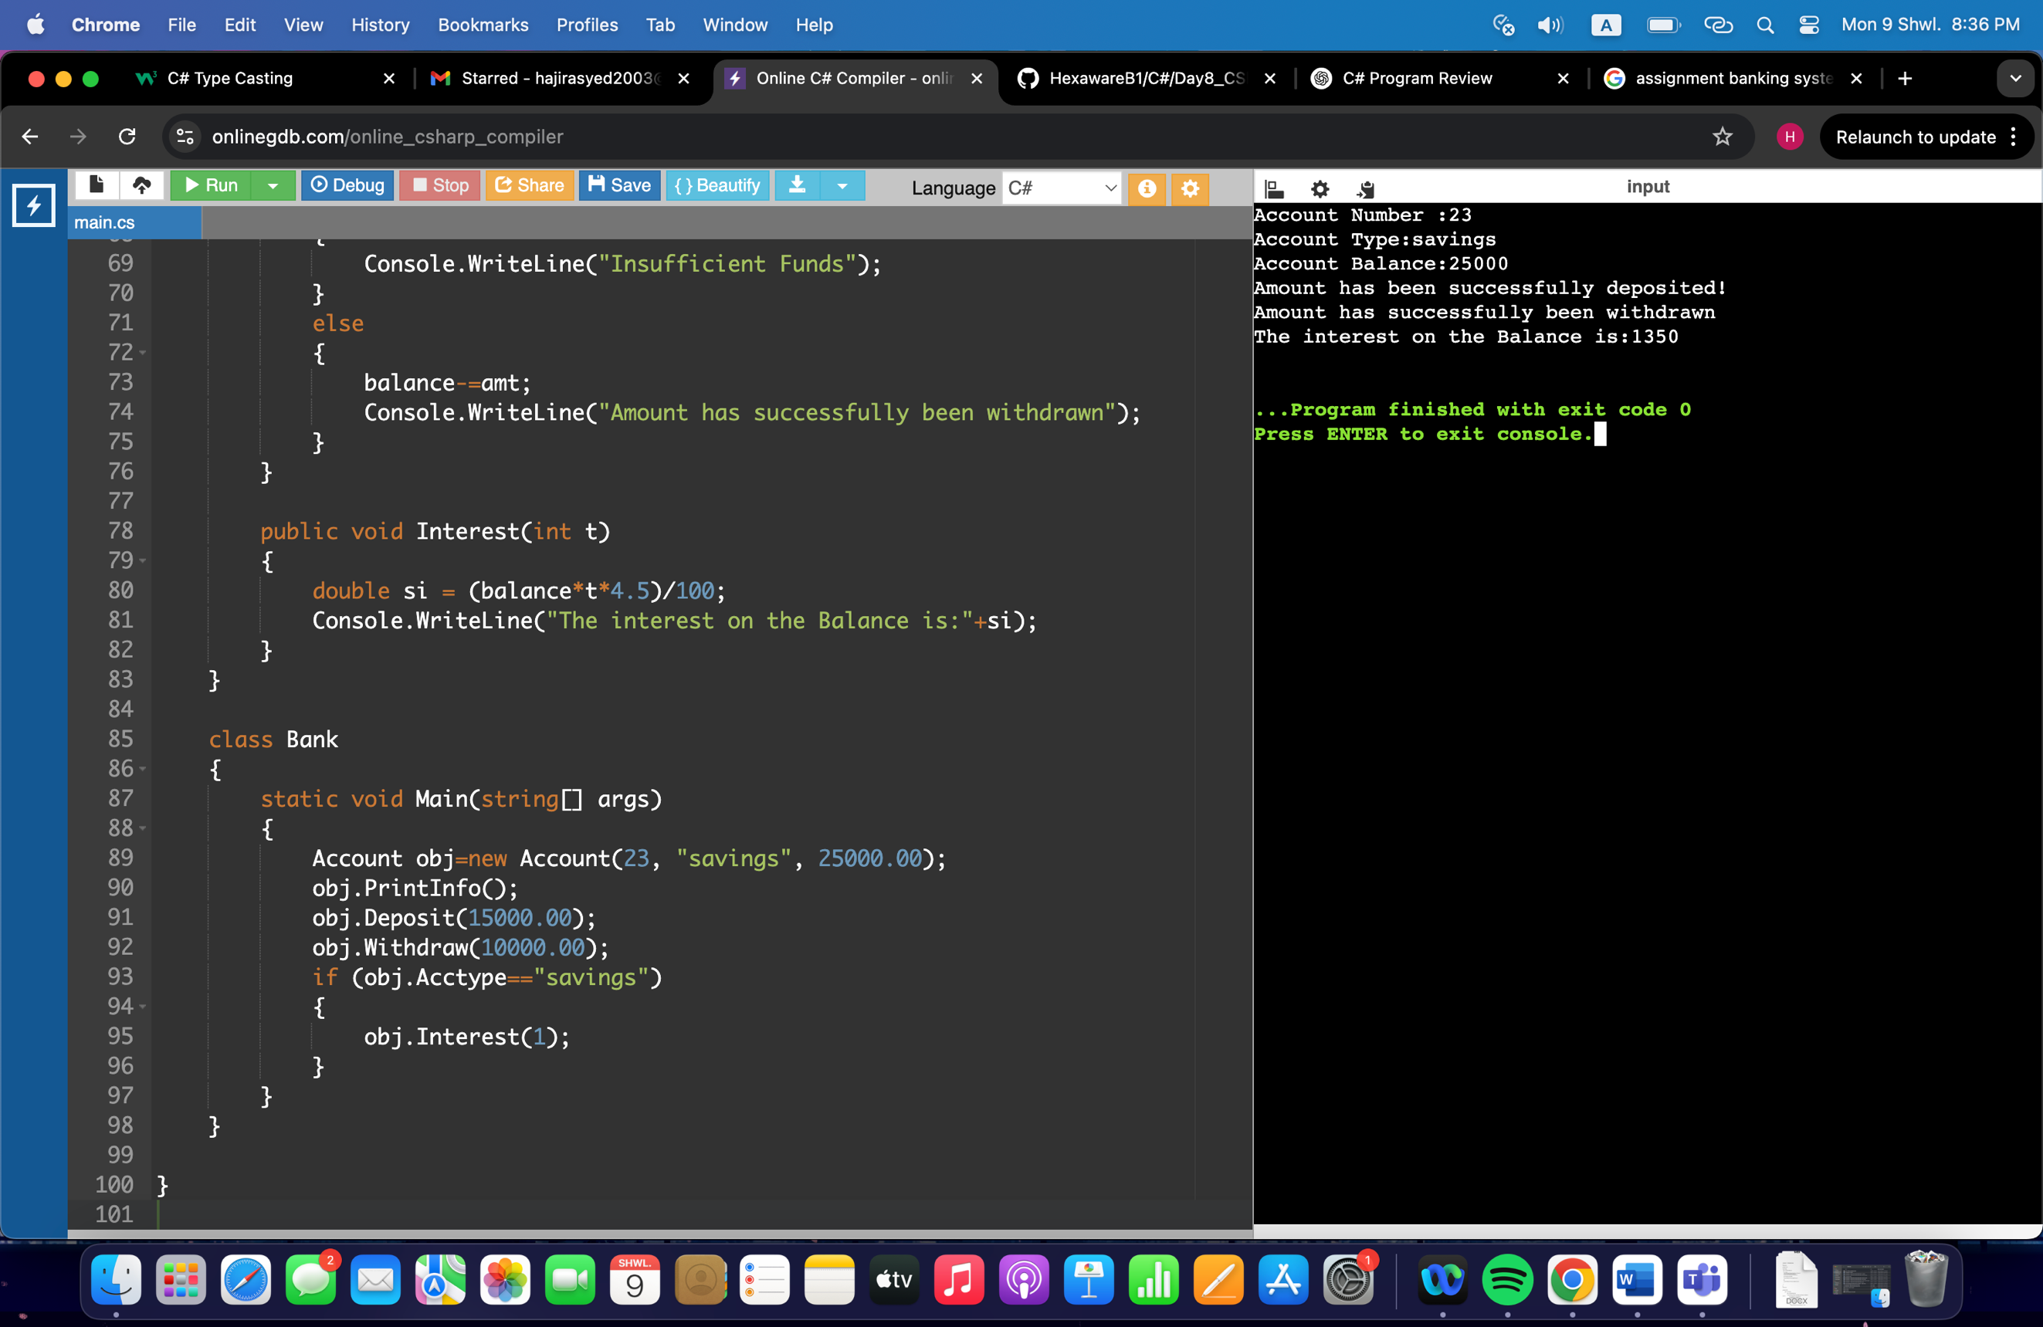

8)

using System;

namespace Task8

{

class Account

{

public int accnum;

public double balance;

public Account()

{

Console.WriteLine("Account Details");

accnum=0;

balance=0;

}

public Account(int a, double b)

{

accnum=a;

balance=b;

}

public void Deposit(int amt)

{

balance+=amt;

Console.WriteLine("The amount deposited is:"+amt);

Console.WriteLine("Total Balance:"+balance);

}

public virtual void Withdraw(int amt)

{

if (amt>balance)

{

Console.WriteLine("Insufficient Funds!");

}

else

{

balance-=amt;

Console.WriteLine("The amount withdrawn is:"+amt);

Console.WriteLine("Total Balance:"+balance);

}

}

public void Deposit(float amt)

{

balance+=amt;

Console.WriteLine("The amount deposited is:"+amt);

Console.WriteLine("Total Balance:"+balance);

}

public virtual void Withdraw(float amt)

{

if (amt>balance)

{

Console.WriteLine("Insufficient Funds!");

}

else

{

balance-=amt;

Console.WriteLine("The amount withdrawn is:"+amt);

Console.WriteLine("Total Balance:"+balance);

}

}

public void Deposit(double amt)

{

balance+=amt;

Console.WriteLine("The amount deposited is:"+amt);

Console.WriteLine("Total Balance:"+balance);

}

public virtual void Withdraw(double amt)

{

if (amt>balance)

{

Console.WriteLine("Insufficient Funds!");

}

else

{

balance-=amt;

Console.WriteLine("The amount withdrawn is:"+amt);

Console.WriteLine("Total Balance:"+balance);

}

}

public virtual void calculate_interest(int time, double rate)

{

double interest=(balance*time*rate)/100;

Console.WriteLine("The total Interest obtained (base class) is:"+interest);

}

}

class SavingsAccount:Account

{

public override void calculate_interest(int time, double rate)

{

double interest=(balance*time*rate)/100;

Console.WriteLine("The total Interest obtained on Savings Account is:"+interest);

}

}

class CurrentAccount:Account

{

private int l;

public CurrentAccount()

{

l=1000;

}

public override void Withdraw(int amt)

{

if (amt>(balance+l))

{

Console.WriteLine("Insufficient Funds!");

}

else if (amt<=(balance+l) && amt>balance)

{

balance-=amt;

Console.WriteLine("The amount Withdrawn including the OverdraftLimit is:"+amt);

Console.WriteLine("Total Balance:"+balance);

}

else

{

balance-=amt;

Console.WriteLine("The amount withdrawn is:"+amt);

Console.WriteLine("Total Balance:"+balance);

}

}

public override void Withdraw(double amt)

{

if (amt>(balance+l))

{

Console.WriteLine("Insufficient Funds!");

}

else if (amt<=(balance+l) && amt>balance)

{

balance-=amt;

Console.WriteLine("The amount Withdrawn including the OverdraftLimit is:"+amt);

Console.WriteLine("Total Balance:"+balance);

}

else

{

balance-=amt;

Console.WriteLine("The amount withdrawn is:"+amt);

Console.WriteLine("Total Balance:"+balance);

}

}

public override void Withdraw(float amt)

{

if (amt>(balance+l))

{

Console.WriteLine("Insufficient Funds!");

}

else if (amt<=(balance+l) && amt>balance)

{

balance-=amt;

Console.WriteLine("The amount Withdrawn including the OverdraftLimit is:"+amt);

Console.WriteLine("Total Balance:"+balance);

}

else

{

balance-=amt;

Console.WriteLine("The amount withdrawn is:"+amt);

Console.WriteLine("Total Balance:"+balance);

}

}

}

class Bank

{

static void Main(string[] args)

{

Console.WriteLine("Choose 1 for savings account, 2 for current account");

int opt=Convert.ToInt32(Console.ReadLine());

switch(opt)

{

case 1:

Console.WriteLine("Choose an option 1 for Deposit and 2 for withdraw");

Console.WriteLine("Enter account number, balance and amount to deposit/withdraw:");

int ch=Convert.ToInt32(Console.ReadLine());

int n=Convert.ToInt32(Console.ReadLine());

double bal2=Convert.ToDouble(Console.ReadLine());

double amount=Convert.ToDouble(Console.ReadLine());

SavingsAccount obj=new SavingsAccount();

obj.accnum=n;

obj.balance=bal2;

if (ch==1)

{

obj.Deposit(amount);

}

else if (ch==2)

{

obj.Withdraw(amount);

}

else

{

Console.WriteLine("Enter valid choices.");

}

break;

case 2:

Console.WriteLine("Choose an option 1 for Deposit and 2 for withdraw");

Console.WriteLine("Enter account number, balance and amount to deposit/withdraw:");

int ch2=Convert.ToInt32(Console.ReadLine());

int n2=Convert.ToInt32(Console.ReadLine());

double bal3=Convert.ToDouble(Console.ReadLine());

double amount2=Convert.ToDouble(Console.ReadLine());

CurrentAccount obj2=new CurrentAccount();

obj2.accnum=n2;

obj2.balance=bal3;

if (ch2==1)

{

obj2.Deposit(amount2);

}

else if (ch2==2)

{

obj2.Withdraw(amount2);

}

else

{

Console.WriteLine("Enter valid choices.");

}

break;

default:

Console.WriteLine("Enter Valid Choices.");

break;

}

}

}

}

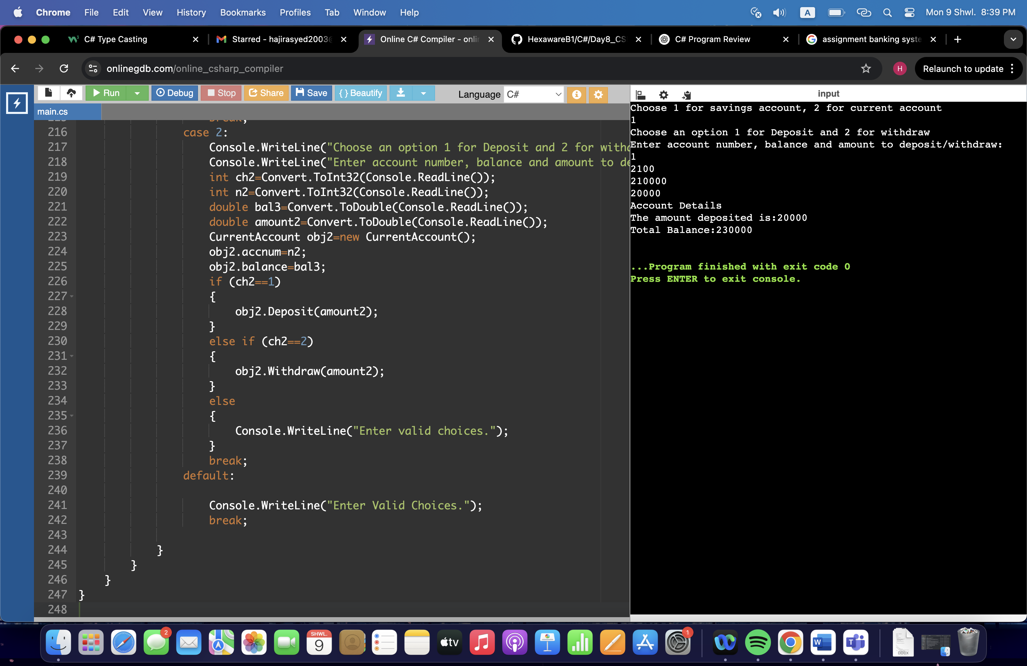

9)

using System;

namespace Task9

{

abstract class BankAccount

{

public int accnum;

public string cname;

public double balance;

public double amount;

public BankAccount()

{

accnum=0;

cname="None";

balance=0;

amount=0;

}

public BankAccount(int a, string n, double b, double amm)

{

accnum=a;

cname=n;

balance=b;

amount=amm;

}

public void Printinfo()

{

Console.WriteLine("Account Number :"+ accnum);

Console.WriteLine("Customer Name: " + cname);

Console.WriteLine("Balance: " + balance);

}

abstract public void deposit(double amm);

abstract public void withdraw(double amm);

abstract public void calculate_interest();

}

class SavingsAccount:BankAccount

{

public double rate;

public SavingsAccount()

{

rate=0;

}

public SavingsAccount(int r)

{

rate=r;

}

public override void deposit(double amt)

{

balance+=amt;

Console.WriteLine("The amount deposited is:"+amt);

Console.WriteLine("Total Balance:"+balance);

}

public override void withdraw(double amt)

{

if (amt>balance)

{

Console.WriteLine("Insufficient Funds!");

}

else

{

balance-=amt;

Console.WriteLine("The amount withdrawn is:"+amt);

Console.WriteLine("Total Balance:"+balance);

}

}

public override void calculate_interest()

{

double interest=(balance*1*rate)/100;

Console.WriteLine("The total Interest obtained on Savings Account is:"+interest);

}

}

class CurrentAccount:BankAccount

{

public int l=1000;

public double rate;

public CurrentAccount()

{

rate=0;

}

public CurrentAccount(int r)

{

rate=r;

}

public override void deposit(double amt)

{

balance+=amt;

Console.WriteLine("The amount deposited is:"+amt);

Console.WriteLine("Total Balance:"+balance);

}

public override void withdraw(double amt)

{

if (amt>(balance+l))

{

Console.WriteLine("Insufficient Funds!");

}

else if (amt<=(balance+l) && amt>balance)

{

balance-=amt;

Console.WriteLine("The amount Withdrawn including the OverdraftLimit is:"+amt);

Console.WriteLine("Total Balance:"+balance);

}

else

{

balance-=amt;

Console.WriteLine("The amount withdrawn is:"+amt);

Console.WriteLine("Total Balance:"+balance);

}

}

public override void calculate_interest()

{

double interest=(balance*1*rate)/100;

Console.WriteLine("The total Interest obtained on Savings Account is:"+interest);

}

}

class Bank

{

static void Main(string[] args)

{

Console.WriteLine("Choose 1 for savings account, 2 for current account");

int opt=Convert.ToInt32(Console.ReadLine());

switch(opt)

{

case 1:

Console.WriteLine("Choose an option 1 for Deposit and 2 for withdraw");

Console.WriteLine("Enter account number, name, balance and amount to deposit/withdraw:");

int ch=Convert.ToInt32(Console.ReadLine());

int n=Convert.ToInt32(Console.ReadLine());

string nam=Console.ReadLine();

double bal2=Convert.ToDouble(Console.ReadLine());

double amount=Convert.ToDouble(Console.ReadLine());

SavingsAccount obj=new SavingsAccount();

obj.accnum=n;

obj.balance=bal2;

obj.cname=nam;

if (ch==1)

{

obj.deposit(amount);

}

else if (ch==2)

{

obj.withdraw(amount);

}

else

{

Console.WriteLine("Enter valid choices.");

}

break;

case 2:

Console.WriteLine("Choose an option 1 for Deposit and 2 for withdraw");

Console.WriteLine("Enter account number, name, balance and amount to deposit/withdraw:");

int ch2=Convert.ToInt32(Console.ReadLine());

int n2=Convert.ToInt32(Console.ReadLine());

string nam2=Console.ReadLine();

double bal3=Convert.ToDouble(Console.ReadLine());

double amount2=Convert.ToDouble(Console.ReadLine());

CurrentAccount obj2=new CurrentAccount();

obj2.accnum=n2;

obj2.balance=bal3;

obj2.cname=nam2;

if (ch2==1)

{

obj2.deposit(amount2);

}

else if (ch2==2)

{

obj2.withdraw(amount2);

}

else

{

Console.WriteLine("Enter valid choices.");

}

break;

default:

Console.WriteLine("Enter Valid Choices.");

break;

}

}

}

}

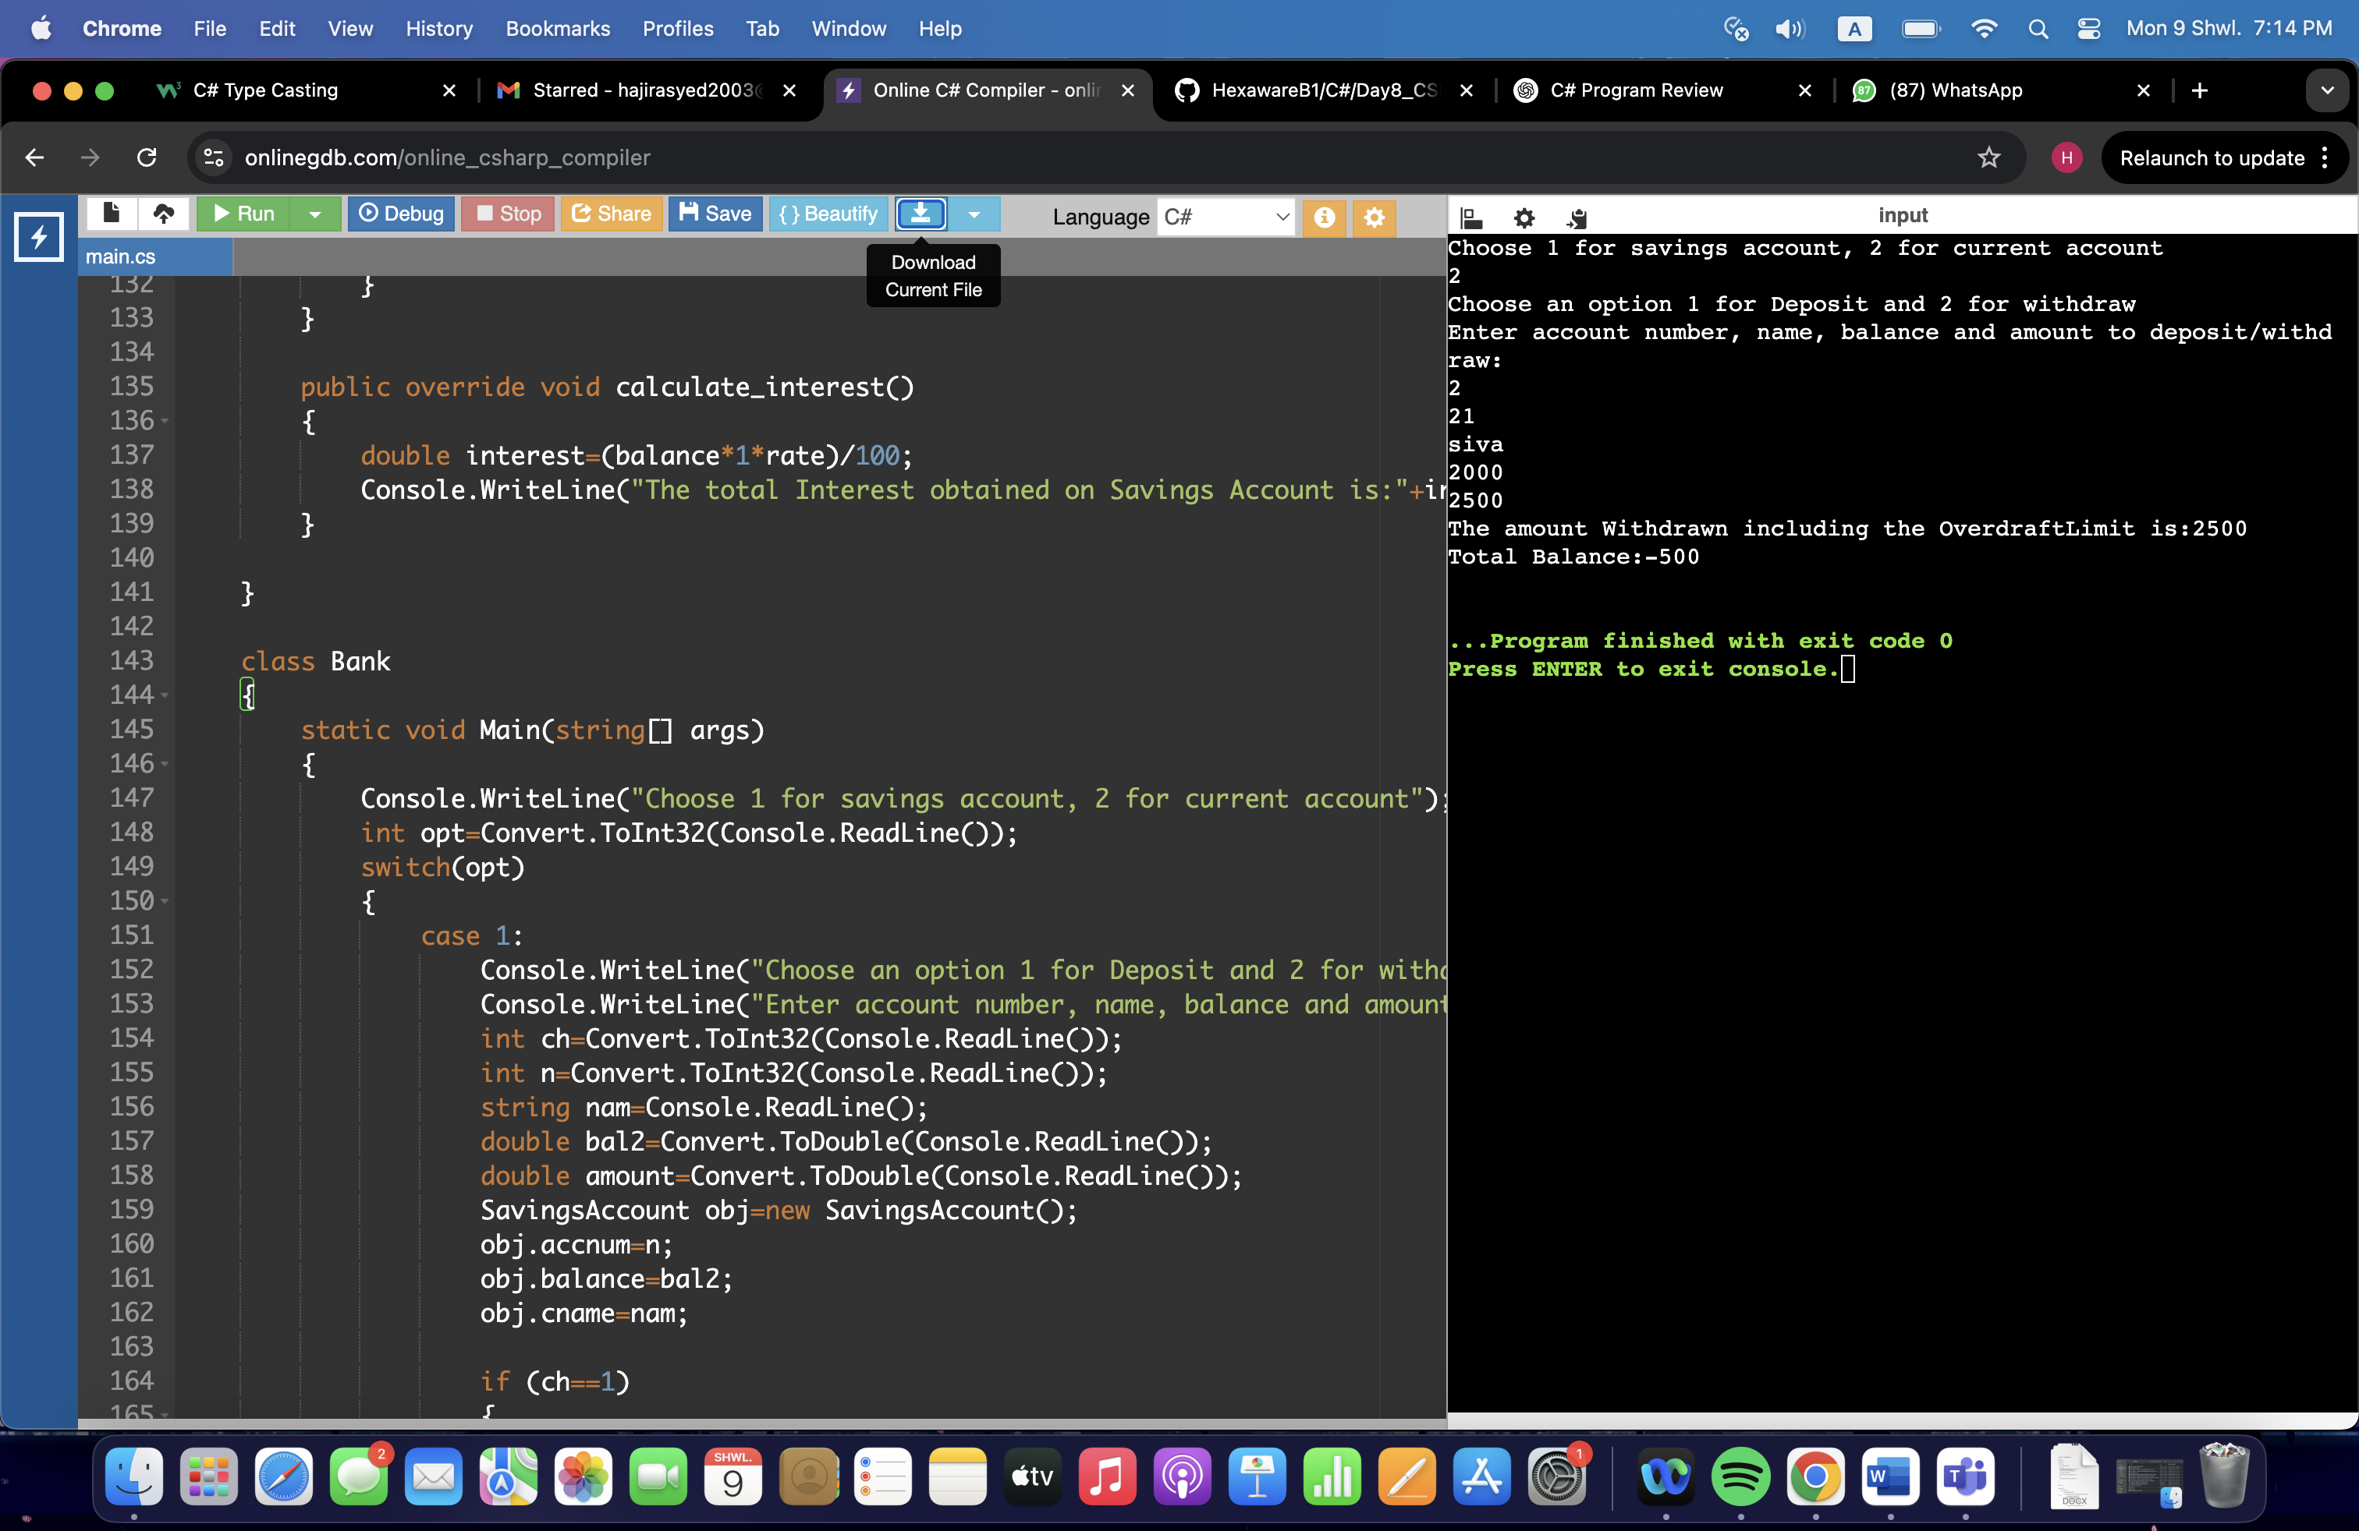

10)

using System;

using System.Collections.Generic;

namespace Task10

{

class Customer

{

private int customerId;

private string firstname;

private string lastname;

private string email;

private string phone;

private string address;

public Customer()

{

customerId = 0;

firstname = "none";

lastname = "none";

email = "none";

phone = "none";

address = "none";

}

public Customer(int id, string f, string l, string e, string num, string a)

{

customerId = id;

firstname = f;

lastname = l;

email = e;

phone = num;

address = a;

}

public int CustomerId

{

get { return customerId; }

set { customerId = value; }

}

public string Firstname

{

get { return firstname; }

set { firstname = value; }

}

public string Lastname

{

get { return lastname; }

set { lastname = value; }

}

public string Email

{

get { return email; }

set { email = value; }

}

public string Phone

{

get { return phone;}

set { phone = value; }

}

public string Address

{

get { return address;}

set { address = value; }

}

public void PrintInfo()

{

Console.WriteLine("Customer ID: " + customerId);

Console.WriteLine("Name: " + firstname + " " + lastname);

Console.WriteLine("Email: " + email);

Console.WriteLine("Phone: " + phone);

Console.WriteLine("Address: " + address);

}

}

class Account

{

private int accnum;

private string acctype;

private double balance;

private string cname;

public Account()

{

accnum = 0;

acctype = "savings";

balance = 0;

cname = "None";

}

public Account(int a, string t, double b, string n)

{

accnum = a;

acctype = t;

balance = b;

cname = n;

}

public int Accnum

{

get { return accnum; }

set { accnum = value; }

}

public string Acctype

{

get { return acctype; }

set { acctype = value; }

}

public double Balance

{

get { return balance; }

set { balance = value; }

}

public string Cname

{

get { return cname; }

set { cname = value; }

}

public void PrintInfo()

{

Console.WriteLine("Account Number: " + accnum);

Console.WriteLine("Account Type: " + acctype);

Console.WriteLine("Account Balance: " + balance);

Console.WriteLine("Customer Name: " + cname);

}

public void Deposit(double amt)

{

balance += amt;

Console.WriteLine("Amount has been successfully deposited!");

}

public void Withdraw(double amt)

{

if (amt > balance)

Console.WriteLine("Insufficient Funds");

else

{

balance -= amt;

Console.WriteLine("Amount has been successfully withdrawn");

}

}

}

class Bank

{

private List<Account> accounts = new List<Account>();

private int nextAccNo = 1001;

public void CreateAccount(Customer cust, string accType, float balance)

{

string fullName = cust.Firstname + " " + cust.Lastname;

Account acc = new Account(nextAccNo++, accType, balance, fullName);

accounts.Add(acc);

Console.WriteLine("Account has been created!");

acc.PrintInfo();

}

public double GetBalance(int accNo)

{

foreach (var acc in accounts)

if (acc.Accnum == accNo)

return acc.Balance;

return -1;

}

public void Deposit(int accNo, float amount)

{

foreach (var acc in accounts)

{

if (acc.Accnum == accNo)

{

acc.Deposit(amount);

return;

}

}

Console.WriteLine("Account not found.");

}

public void Withdraw(int accNo, float amount)

{

foreach (var acc in accounts)

{

if (acc.Accnum == accNo)

{

acc.Withdraw(amount);

return;

}

}

Console.WriteLine("Account not found.");

}

public void Transfer(int fromAcc, int toAcc, float amount)

{

Account from = null, to = null;

foreach (var acc in accounts)

{

if (acc.Accnum == fromAcc) from = acc;

if (acc.Accnum == toAcc) to = acc;

}

if (from == null || to == null)

{

Console.WriteLine("One or both accounts not found.");

return;

}

if (from.Balance < amount)

{

Console.WriteLine("Transfer failed due to insufficient funds.");

return;

}

from.Withdraw(amount);

to.Deposit(amount);

Console.WriteLine("Transfer complete.");

}

public void GetAccountDetails(int accNo)

{

foreach (var acc in accounts)

if (acc.Accnum == accNo)

acc.PrintInfo();

}

}

class BankApp

{

static void Main(string[] args)

{

Bank bank = new Bank();

while (true)

{

Console.WriteLine("MENU:");

Console.WriteLine("1. Create account");

Console.WriteLine("2. Deposit");

Console.WriteLine("3. Withdraw");

Console.WriteLine("4. Get Balance");

Console.WriteLine("5. Transfer");

Console.WriteLine("6. Get Account Details");

Console.WriteLine("7. Exit");

Console.Write("Enter your choice: ");

int choice = Convert.ToInt32(Console.ReadLine());

switch (choice)

{

case 1:

Console.Write("Enter Customer ID: ");

int cid = int.Parse(Console.ReadLine());

Console.Write("First Name: ");

string fname = Console.ReadLine();

Console.Write("Last Name: ");

string lname = Console.ReadLine();

Console.Write("Email: ");

string email = Console.ReadLine();

Console.Write("Phone: ");

string phone = Console.ReadLine();

Console.Write("Address: ");

string address = Console.ReadLine();

Customer cust = new Customer(cid, fname, lname, email, phone, address);

Console.Write("What Account Type? (Savings/Current): ");

string type = Console.ReadLine();

Console.Write("Initial Balance: ");

float balance = float.Parse(Console.ReadLine());

bank.CreateAccount(cust, type, balance);

break;

case 2:

Console.Write("Enter Account No: ");

int dacc = int.Parse(Console.ReadLine());

Console.Write("Amount to deposit: ");

float damt = float.Parse(Console.ReadLine());

bank.Deposit(dacc, damt);

break;

case 3:

Console.Write("Enter Account No: ");

int wacc = int.Parse(Console.ReadLine());

Console.Write("Amount to withdraw: ");

float wamt = float.Parse(Console.ReadLine());

bank.Withdraw(wacc, wamt);

break;

case 4:

Console.Write("Enter Account No: ");

int gbacc = int.Parse(Console.ReadLine());

double bal = bank.GetBalance(gbacc);

if (bal != -1)

Console.WriteLine("Balance: " + bal);

else

Console.WriteLine("Account not found.");

break;

case 5:

Console.Write("From Account No: ");

int fAcc = int.Parse(Console.ReadLine());

Console.Write("To Account No: ");

int tAcc = int.Parse(Console.ReadLine());

Console.Write("Amount to transfer: ");

float amt = float.Parse(Console.ReadLine());

bank.Transfer(fAcc, tAcc, amt);

break;

case 6:

Console.Write("Enter Account No: ");

int accid = int.Parse(Console.ReadLine());

bank.GetAccountDetails(accid);

break;

case 7:

Console.WriteLine("Exit");

return;

default:

Console.WriteLine("Enter valid choice");

break;

}

}

}

}

}

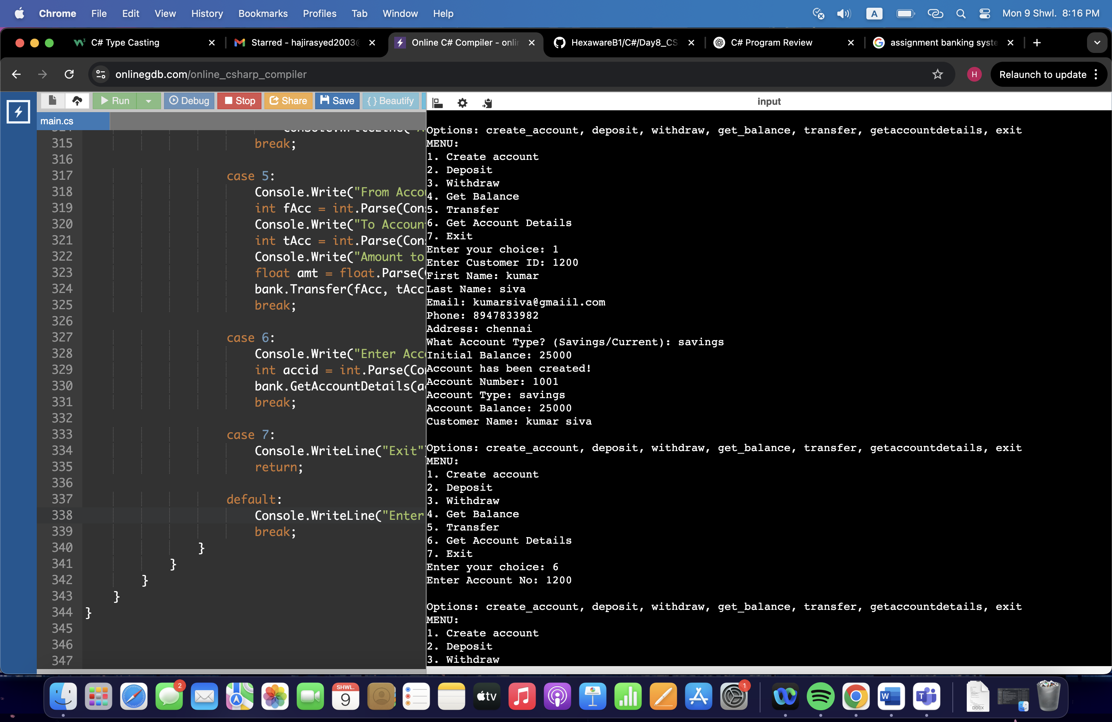

11)

using System;

using System.Collections.Generic;

namespace Task11

{

public interface ICustomerServiceProvider

{

float GetAccountBalance(long accNo);

float Deposit(long accNo, float amount);

float Withdraw(long accNo, float amount);

void Transfer(long fromAccNo, long toAccNo, float amount);

void GetAccountDetails(long accNo);

}

public interface IBankServiceProvider

{

void CreateAccount(Customer customer, string accType, float balance);

void ListAccounts();

void CalculateInterest();

}

public class Customer

{

public int CustId { get; set; }

public string FirstName { get; set; }

public string LastName { get; set; }

public string Email { get; set; }

public string PhoneNumber { get; set; }

public string Address { get; set; }

public Customer(int custId, string firstName, string lastName, string email, string phoneNumber, string address)

{

CustId = custId;

FirstName = firstName;

LastName = lastName;

Email = email;

PhoneNumber = phoneNumber;

Address = address;

}

public void PrintInfo()

{

Console.WriteLine("Customer ID: " + CustId);

Console.WriteLine("Name: " + FirstName + " " + LastName);

Console.WriteLine("Email: " + Email);

Console.WriteLine("Phone: " + PhoneNumber);

Console.WriteLine("Address: " + Address);

}

}

public abstract class Account

{

private static long lastAccNo = 1000;

public long AccountNumber { get; private set; }

public string AccountType { get; set; }

public float Balance { get; set; }

public Customer Customer { get; set; }

public Account(string accType, float balance, Customer customer)

{

AccountNumber = ++lastAccNo;

AccountType = accType;

Balance = balance;

Customer = customer;

}

public abstract void Withdraw(float amount);

public virtual void Deposit(float amount) => Balance += amount;

public abstract void CalculateInterest();

}

public class SavingsAccount : Account

{

private float interestRate = 0.04f;

public SavingsAccount(float balance, Customer customer)

: base("Savings", balance < 500 ? 500 : balance, customer) { }

public override void Withdraw(float amount)

{

if (Balance - amount >= 500)

Balance -= amount;

else

Console.WriteLine("Minimum balance of 500 must be maintained");

}

public override void CalculateInterest()

{

float interest = Balance * interestRate;

Balance += interest;

}

}

public class CurrentAccount : Account

{

private float overdraftLimit = 1000;

public CurrentAccount(float balance, Customer customer)

: base("Current", balance, customer) { }

public override void Withdraw(float amount)

{

if (Balance + overdraftLimit >= amount)

Balance -= amount;

else

Console.WriteLine("Overdraft limit exceeded.");

}

public override void CalculateInterest() { }

}

public class ZeroBalanceAccount : Account

{

public ZeroBalanceAccount(float balance, Customer customer)

: base("ZeroBalance", balance, customer) { }

public override void Withdraw(float amount)

{

if (amount <= Balance)

Balance -= amount;

else

Console.WriteLine("Insufficient funds");

}

public override void CalculateInterest() { }

}

public class CustomerServiceProviderImpl : ICustomerServiceProvider

{

protected List<Account> accountList = new List<Account>();

protected Account FindAccount(long accNo)

{

return accountList.Find(a => a.AccountNumber == accNo);

}

public float GetAccountBalance(long accNo)

{

var acc = FindAccount(accNo);

if (acc != null)

return acc.Balance;

Console.WriteLine("Account not found.");

return -1;

}

public float Deposit(long accNo, float amount)

{

var acc = FindAccount(accNo);

if (acc != null)

{

acc.Deposit(amount);

return acc.Balance;

}

Console.WriteLine("Account not found.");

return -1;

}

public float Withdraw(long accNo, float amount)

{

var acc = FindAccount(accNo);

if (acc != null)

{

acc.Withdraw(amount);

return acc.Balance;

}

Console.WriteLine("Account not found.");

return -1;

}

public void Transfer(long fromAccNo, long toAccNo, float amount)

{

var from = FindAccount(fromAccNo);

var to = FindAccount(toAccNo);

if (from != null && to != null)

{

float preBalance = from.Balance;

from.Withdraw(amount);

if (from.Balance < preBalance)

{

to.Deposit(amount);

Console.WriteLine("Transfer successful.");

}

}

else

Console.WriteLine("Account not found.");

}

public void GetAccountDetails(long accNo)

{

var acc = FindAccount(accNo);

if (acc != null)

{

Console.WriteLine("Account No:"+acc.AccountNumber);

Console.WriteLine("Type:"+acc.AccountType);

Console.WriteLine("Balance:"+acc.Balance);

acc.Customer.PrintInfo();

}

else

Console.WriteLine("Account not found.");

}

}

public class BankServiceProviderImpl : CustomerServiceProviderImpl, IBankServiceProvider

{

private string branchName = "Main Branch";

private string branchAddress = "City Center";

public void CreateAccount(Customer cust, string accType, float balance)

{

Account acc = null;

string accTypeLower = accType.ToLower();

if (accTypeLower == "savings")

acc = new SavingsAccount(balance, cust);

else if (accTypeLower == "current")

acc = new CurrentAccount(balance, cust);

else if (accTypeLower == "zerobalance")

acc = new ZeroBalanceAccount(balance, cust);

if (acc != null)

{

accountList.Add(acc);

Console.WriteLine("Account created successfully.");

GetAccountDetails(acc.AccountNumber);

}

else

Console.WriteLine("Invalid");

}

public void ListAccounts()

{

foreach (var acc in accountList)

{

Console.WriteLine("AccNo:"+acc.AccountNumber);

Console.WriteLine("Type:"+acc.AccountType);

Console.WriteLine("Balance:"+acc.Balance);

}

}

public void CalculateInterest()

{

foreach (var acc in accountList)

acc.CalculateInterest();

}

}

class BankApp

{

static void Main(string[] args)

{

BankServiceProviderImpl bank = new BankServiceProviderImpl();

while (true)

{

Console.WriteLine("MENU");

Console.WriteLine("1. Create Account");

Console.WriteLine("2. Deposit");

Console.WriteLine("3. Withdraw");

Console.WriteLine("4. Get Balance");

Console.WriteLine("5. Transfer");

Console.WriteLine("6. Get Account Details");

Console.WriteLine("7. List Accounts");

Console.WriteLine("8. Exit");

int opt=Convert.ToInt32(Console.ReadLine());

switch (opt)

{

case 1:

Console.Write("Customer ID: ");

int cid = int.Parse(Console.ReadLine());

Console.Write("First Name: ");

string fname = Console.ReadLine();

Console.Write("Last Name: ");

string lname = Console.ReadLine();

Console.Write("Email: ");

string email = Console.ReadLine();

Console.Write("Phone: ");

string phone = Console.ReadLine();

Console.Write("Address: ");

string address = Console.ReadLine();

Customer cust = new Customer(cid, fname, lname, email, phone, address);

Console.Write("Account Type (savings/current/zerobalance): ");

string type = Console.ReadLine();

Console.Write("Initial Balance: ");

float bal = float.Parse(Console.ReadLine());

bank.CreateAccount(cust, type, bal);

break;

case 2:

Console.Write("Account Number: ");

long dacc = long.Parse(Console.ReadLine());

Console.Write("Amount: ");

float damt = float.Parse(Console.ReadLine());

bank.Deposit(dacc, damt);

break;

case 3:

Console.Write("Account Number: ");

long wacc = long.Parse(Console.ReadLine());

Console.Write("Amount: ");

float wamt = float.Parse(Console.ReadLine());

bank.Withdraw(wacc, wamt);

break;

case 4:

Console.Write("Account Number: ");

long gacc = long.Parse(Console.ReadLine());

Console.WriteLine("Balance: " + bank.GetAccountBalance(gacc));

break;

case 5:

Console.Write("From Account: ");

long fAcc = long.Parse(Console.ReadLine());

Console.Write("To Account: ");

long tAcc = long.Parse(Console.ReadLine());

Console.Write("Amount: ");

float amt = float.Parse(Console.ReadLine());

bank.Transfer(fAcc, tAcc, amt);

break;

case 6:

Console.Write("Account Number: ");

long acc = long.Parse(Console.ReadLine());

bank.GetAccountDetails(acc);

break;

case 7:

bank.ListAccounts();

break;

case 8:

return;

default:

Console.WriteLine("Enter correct option!");

break;

}

}

}

}

}

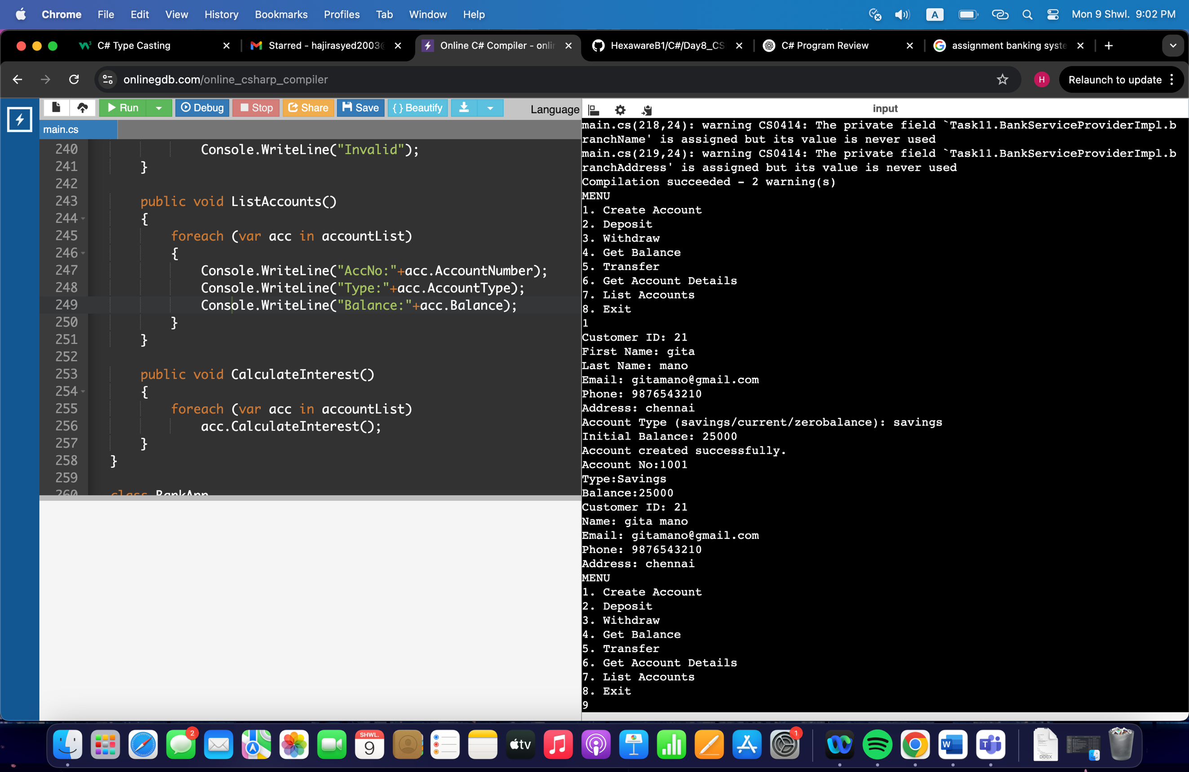

12)

using System;

using System.Collections.Generic;

namespace Task12

{

public abstract class Account

{

public long AccountNumber { get; set; }

public string CustomerName { get; set; }

public float Balance { get; set; }

public Account(long accno, string name, float balance)

{

AccountNumber = accno;

CustomerName = name;

Balance = balance;

}

public virtual void Deposit(float amount)

{

Balance += amount;

}

public abstract void Withdraw(float amount);

public abstract void CalculateInterest();

}

public class SavingsAccount : Account

{

private float interestRate = 0.04f;

public SavingsAccount(long accno, string name, float balance) : base(accno, name, balance) { }

public override void Withdraw(float amount)

{

if (Balance - amount >= 500)

Balance -= amount;

else

throw new InsufficientFundException("Minimum balance of 500 must be maintained.");

}

public override void CalculateInterest()

{

Balance += Balance * interestRate;

}

}

public class CurrentAccount : Account

{

private float overdraftLimit = 1000;

public CurrentAccount(long accno, string name, float balance) : base(accno, name, balance) { }

public override void Withdraw(float amount)

{

if (Balance + overdraftLimit >= amount)

Balance -= amount;

else

throw new OverDraftLimitExceededException("Overdraft limit exceeded.");

}

public override void CalculateInterest() { }

}

public class FixedDepositAccount : Account

{

private float interestRate = 0.08f;

public FixedDepositAccount(long accno, string name, float balance) : base(accno, name, balance) { }

public override void Withdraw(float amount)

{

if (amount <= Balance)

Balance -= amount;

else

throw new InsufficientFundException("Insufficient funds.");

}

public override void CalculateInterest()

{

Balance += Balance * interestRate;

}

}

public class InsufficientFundException : Exception

{

public InsufficientFundException(string message) : base(message) { }

}

public class InvalidAccountException : Exception

{

public InvalidAccountException(string message) : base(message) { }

}

public class OverDraftLimitExceededException : Exception

{

public OverDraftLimitExceededException(string message) : base(message) { }

}

public interface CustomerServiceProvider

{

void CreateAccount(Account acc);

void Deposit(long accNo, float amount);

void Withdraw(long accNo, float amount);

void Transfer(long fromAccNo, long toAccNo, float amount);

void GetAccountDetails(long accNo);

}

public interface BankServiceProvider

{

void CalculateInterest();

}

public class CustomerServiceProviderImpl : CustomerServiceProvider, BankServiceProvider

{

protected List<Account> accountList = new List<Account>();

public void CreateAccount(Account acc)

{

accountList.Add(acc);

Console.WriteLine("Account created successfully!");

}

protected Account FindAccount(long accNo)

{

var acc = accountList.Find(a => a.AccountNumber == accNo);

if (acc == null)

throw new InvalidAccountException("Account number " + accNo + " is invalid.");

return acc;

}

public void Deposit(long accNo, float amount)

{

var acc = FindAccount(accNo);

acc.Deposit(amount);

}

public void Withdraw(long accNo, float amount)

{

var acc = FindAccount(accNo);

acc.Withdraw(amount);

}

public void Transfer(long fromAccNo, long toAccNo, float amount)

{

var from = FindAccount(fromAccNo);

var to = FindAccount(toAccNo);

from.Withdraw(amount);

to.Deposit(amount);

Console.WriteLine("Transfer successful.");

}

public void GetAccountDetails(long accNo)

{

var acc = FindAccount(accNo);

Console.WriteLine($"Account Number: {acc.AccountNumber}");

Console.WriteLine($"Customer Name: {acc.CustomerName}");

Console.WriteLine($"Balance: {acc.Balance}");

}

public void CalculateInterest()

{

foreach (var acc in accountList)

{

acc.CalculateInterest();

}

}

}

class Program

{

static void Main(string[] args)

{

CustomerServiceProviderImpl bank = new CustomerServiceProviderImpl();

while (true)

{

Console.WriteLine("1. Create Account");

Console.WriteLine("2. Deposit");

Console.WriteLine("3. Withdraw");

Console.WriteLine("4. Transfer");

Console.WriteLine("5. Account Details");

Console.WriteLine("6. Calculate Interest");

Console.WriteLine("7. Exit");

Console.Write("Enter your choice: ");

int ch = int.Parse(Console.ReadLine());

try

{

switch (ch)

{

case 1:

Console.Write("Enter Account Number: ");

long accno = long.Parse(Console.ReadLine());

Console.Write("Enter Customer Name: ");

string name = Console.ReadLine();

Console.Write("Enter Initial Balance: ");

float bal = float.Parse(Console.ReadLine());

Console.WriteLine("Account Type: 1. Savings 2. Current 3. FixedDeposit");

int type = int.Parse(Console.ReadLine());

Account acc;

switch (type)

{

case 1:

acc = new SavingsAccount(accno, name, bal);

break;

case 2:

acc = new CurrentAccount(accno, name, bal);

break;

case 3:

acc = new FixedDepositAccount(accno, name, bal);

break;

default:

throw new Exception("Invalid Account Type");

}

bank.CreateAccount(acc);

break;

case 2:

Console.Write("Enter Account Number: ");

long dacc = long.Parse(Console.ReadLine());

Console.Write("Enter Amount: ");

float damt = float.Parse(Console.ReadLine());

bank.Deposit(dacc, damt);

break;

case 3:

Console.Write("Enter Account Number: ");

long wacc = long.Parse(Console.ReadLine());

Console.Write("Enter Amount: ");

float wamt = float.Parse(Console.ReadLine());

bank.Withdraw(wacc, wamt);

break;

case 4:

Console.Write("Enter From Account: ");

long facc = long.Parse(Console.ReadLine());

Console.Write("Enter To Account: ");

long tacc = long.Parse(Console.ReadLine());

Console.Write("Enter Amount: ");

float tamt = float.Parse(Console.ReadLine());

bank.Transfer(facc, tacc, tamt);

break;

case 5:

Console.Write("Enter Account Number: ");

long gacc = long.Parse(Console.ReadLine());

bank.GetAccountDetails(gacc);

break;

case 6:

bank.CalculateInterest();

Console.WriteLine("Interest calculation complete.");

break;

case 7:

return;

default:

Console.WriteLine("Invalid choice");

break;

}

}

catch (InvalidAccountException ex)

{

Console.WriteLine("Error: " + ex.Message);

}

catch (InsufficientFundException ex)

{

Console.WriteLine("Error: " + ex.Message);

}

catch (OverDraftLimitExceededException ex)

{

Console.WriteLine("Error: " + ex.Message);

}

catch (NullReferenceException)

{

Console.WriteLine("Error: Null reference occurred.");

}

catch (Exception ex)

{

Console.WriteLine("Error: " + ex.Message);

}

}

}

}

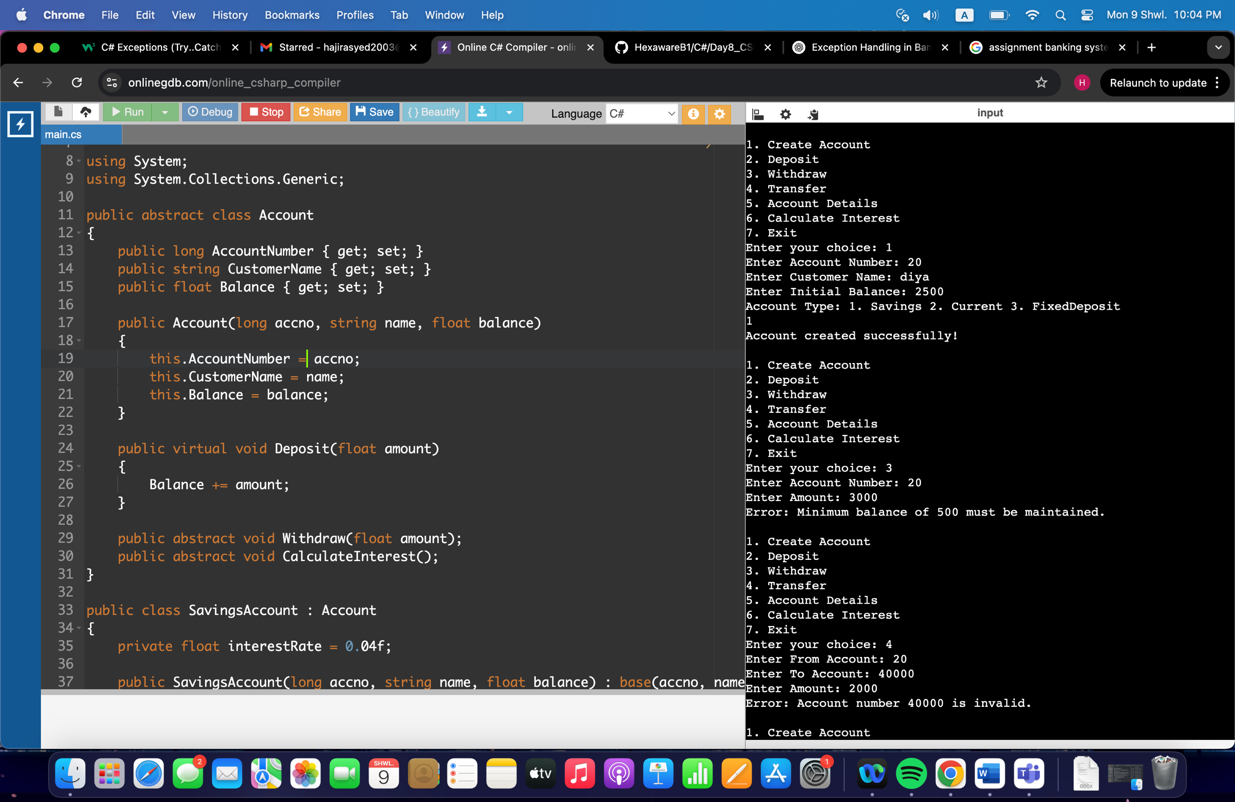

13)

1) The previous program is already as a List

2) The previous program is modified USING DICTIONARY

using System;

using System.Collections.Generic;

namespace Task13

{

public abstract class Account

{

public long AccountNumber { get; set; }

public string CustomerName { get; set; }

public float Balance { get; set; }

public Account(long accno, string name, float balance)

{

AccountNumber = accno;

CustomerName = name;

Balance = balance;

}

public virtual void Deposit(float amount)

{

Balance += amount;

}

public abstract void Withdraw(float amount);

public abstract void CalculateInterest();

}

public class SavingsAccount : Account

{

private float interestRate = 0.04f;

public SavingsAccount(long accno, string name, float balance) : base(accno, name, balance) { }

public override void Withdraw(float amount)

{

if (Balance - amount >= 500)

Balance -= amount;

else

throw new InsufficientFundException("Minimum balance of 500 must be maintained.");

}

public override void CalculateInterest()

{

Balance += Balance * interestRate;

}

}

public class CurrentAccount : Account

{

private float overdraftLimit = 1000;

public CurrentAccount(long accno, string name, float balance) : base(accno, name, balance) { }

public override void Withdraw(float amount)

{

if (Balance + overdraftLimit >= amount)

Balance -= amount;

else

throw new OverDraftLimitExceededException("Overdraft limit exceeded.");

}

public override void CalculateInterest() { }

}

public class FixedDepositAccount : Account

{

private float interestRate = 0.08f;

public FixedDepositAccount(long accno, string name, float balance) : base(accno, name, balance) { }

public override void Withdraw(float amount)

{

if (amount <= Balance)

Balance -= amount;

else

throw new InsufficientFundException("Insufficient funds.");

}

public override void CalculateInterest()

{

Balance += Balance * interestRate;

}

}

public class InsufficientFundException : Exception

{

public InsufficientFundException(string message) : base(message) { }

}

public class InvalidAccountException : Exception

{

public InvalidAccountException(string message) : base(message) { }

}

public class OverDraftLimitExceededException : Exception

{

public OverDraftLimitExceededException(string message) : base(message) { }

}

public interface CustomerServiceProvider

{

void CreateAccount(Account acc);

void Deposit(long accNo, float amount);

void Withdraw(long accNo, float amount);

void Transfer(long fromAccNo, long toAccNo, float amount);

void GetAccountDetails(long accNo);

}

public interface BankServiceProvider

{

void CalculateInterest();

}

public class CustomerServiceProviderImpl : CustomerServiceProvider, BankServiceProvider

{

protected Dictionary<long, Account> accountMap = new Dictionary<long, Account>();

public void CreateAccount(Account acc)

{

if (!accountMap.ContainsKey(acc.AccountNumber))

{

accountMap.Add(acc.AccountNumber, acc);

Console.WriteLine("Account created successfully!");

}

else

{

Console.WriteLine("Account already exists with this account number.");

}

}

protected Account FindAccount(long accNo)

{

if (accountMap.ContainsKey(accNo))

return accountMap[accNo];

throw new InvalidAccountException("Account number " + accNo + " is invalid.");

}

public void Deposit(long accNo, float amount)

{

var acc = FindAccount(accNo);

acc.Deposit(amount);

}

public void Withdraw(long accNo, float amount)

{

var acc = FindAccount(accNo);

acc.Withdraw(amount);

}

public void Transfer(long fromAccNo, long toAccNo, float amount)

{

var from = FindAccount(fromAccNo);

var to = FindAccount(toAccNo);

from.Withdraw(amount);

to.Deposit(amount);

Console.WriteLine("Transfer successful.");

}

public void GetAccountDetails(long accNo)

{

var acc = FindAccount(accNo);

Console.WriteLine($"Account Number: {acc.AccountNumber}");

Console.WriteLine($"Customer Name: {acc.CustomerName}");

Console.WriteLine($"Balance: {acc.Balance}");

}

public void CalculateInterest()

{

foreach (var acc in accountMap.Values)

{

acc.CalculateInterest();

}

}

}

class Program

{

static void Main(string[] args)

{

CustomerServiceProviderImpl bank = new CustomerServiceProviderImpl();

while (true)

{

Console.WriteLine("\n1. Create Account");

Console.WriteLine("2. Deposit");

Console.WriteLine("3. Withdraw");

Console.WriteLine("4. Transfer");

Console.WriteLine("5. Account Details");

Console.WriteLine("6. Calculate Interest");

Console.WriteLine("7. Exit");

Console.Write("Enter your choice: ");

int ch = int.Parse(Console.ReadLine());

try

{

switch (ch)

{

case 1:

Console.Write("Enter Account Number: ");

long accno = long.Parse(Console.ReadLine());

Console.Write("Enter Customer Name: ");

string name = Console.ReadLine();

Console.Write("Enter Initial Balance: ");

float bal = float.Parse(Console.ReadLine());

Console.WriteLine("Account Type: 1. Savings 2. Current 3. FixedDeposit");

int type = int.Parse(Console.ReadLine());

Account acc;

switch (type)

{

case 1:

acc = new SavingsAccount(accno, name, bal);

break;

case 2:

acc = new CurrentAccount(accno, name, bal);

break;

case 3:

acc = new FixedDepositAccount(accno, name, bal);

break;

default:

throw new Exception("Invalid Account Type");

}

bank.CreateAccount(acc);

break;

case 2:

Console.Write("Enter Account Number: ");

long dacc = long.Parse(Console.ReadLine());

Console.Write("Enter Amount: ");

float damt = float.Parse(Console.ReadLine());

bank.Deposit(dacc, damt);

break;

case 3:

Console.Write("Enter Account Number: ");

long wacc = long.Parse(Console.ReadLine());

Console.Write("Enter Amount: ");

float wamt = float.Parse(Console.ReadLine());

bank.Withdraw(wacc, wamt);

break;

case 4:

Console.Write("Enter From Account: ");

long facc = long.Parse(Console.ReadLine());

Console.Write("Enter To Account: ");

long tacc = long.Parse(Console.ReadLine());

Console.Write("Enter Amount: ");

float tamt = float.Parse(Console.ReadLine());

bank.Transfer(facc, tacc, tamt);

break;

case 5:

Console.Write("Enter Account Number: ");

long gacc = long.Parse(Console.ReadLine());

bank.GetAccountDetails(gacc);

break;

case 6:

bank.CalculateInterest();

Console.WriteLine("Interest calculation complete.");

break;

case 7:

return;

default:

Console.WriteLine("Invalid choice");

break;

}

}

catch (InvalidAccountException ex)

{

Console.WriteLine("Error: " + ex.Message);

}

catch (InsufficientFundException ex)

{

Console.WriteLine("Error: " + ex.Message);

}

catch (OverDraftLimitExceededException ex)

{

Console.WriteLine("Error: " + ex.Message);

}

catch (NullReferenceException)

{

Console.WriteLine("Error: Null reference occurred.");

}

catch (Exception ex)

{

Console.WriteLine("Error: " + ex.Message);

}

}

}

}

}

13) 3) The previous program is modified to HASHMAP

using System;

using System.Collections.Generic;

namespace Task13

{

public abstract class Account

{

public long AccountNumber { get; set; }

public string CustomerName { get; set; }

public float Balance { get; set; }

public Account(long accno, string name, float balance)

{

AccountNumber = accno;

CustomerName = name;

Balance = balance;

}

public virtual void Deposit(float amount)

{

Balance += amount;

}

public abstract void Withdraw(float amount);

public abstract void CalculateInterest();

}

public class SavingsAccount : Account

{

private float interestRate = 0.04f;

public SavingsAccount(long accno, string name, float balance) : base(accno, name, balance) { }

public override void Withdraw(float amount)

{

if (Balance - amount >= 500)

Balance -= amount;

else

throw new InsufficientFundException("Minimum balance of 500 must be maintained.");

}

public override void CalculateInterest()

{

Balance += Balance * interestRate;

}

}

public class CurrentAccount : Account

{

private float overdraftLimit = 1000;

public CurrentAccount(long accno, string name, float balance) : base(accno, name, balance) { }

public override void Withdraw(float amount)

{

if (Balance + overdraftLimit >= amount)

Balance -= amount;

else

throw new OverDraftLimitExceededException("Overdraft limit exceeded.");

}

public override void CalculateInterest() { }

}

public class FixedDepositAccount : Account

{

private float interestRate = 0.08f;

public FixedDepositAccount(long accno, string name, float balance) : base(accno, name, balance) { }

public override void Withdraw(float amount)

{

if (amount <= Balance)

Balance -= amount;

else

throw new InsufficientFundException("Insufficient funds.");

}

public override void CalculateInterest()

{

Balance += Balance * interestRate;

}

}

public class InsufficientFundException : Exception

{

public InsufficientFundException(string message) : base(message) { }

}

public class InvalidAccountException : Exception

{

public InvalidAccountException(string message) : base(message) { }

}

public class OverDraftLimitExceededException : Exception

{

public OverDraftLimitExceededException(string message) : base(message) { }

}

public interface CustomerServiceProvider

{

void CreateAccount(Account acc);

void Deposit(long accNo, float amount);

void Withdraw(long accNo, float amount);

void Transfer(long fromAccNo, long toAccNo, float amount);

void GetAccountDetails(long accNo);

}

public interface BankServiceProvider

{

void CalculateInterest();

}

public class CustomerServiceProviderImpl : CustomerServiceProvider, BankServiceProvider

{

protected Dictionary<long, Account> accountMap = new Dictionary<long, Account>();

public void CreateAccount(Account acc)

{

if (accountMap.ContainsKey(acc.AccountNumber))

{

Console.WriteLine("Account with this number already exists!");

return;

}

accountMap[acc.AccountNumber] = acc;

Console.WriteLine("Account created successfully!");

}

protected Account FindAccount(long accNo)

{

if (!accountMap.ContainsKey(accNo))

throw new InvalidAccountException("Account number " + accNo + " is invalid.");

return accountMap[accNo];

}

public void Deposit(long accNo, float amount)

{

var acc = FindAccount(accNo);

acc.Deposit(amount);

}

public void Withdraw(long accNo, float amount)

{

var acc = FindAccount(accNo);

acc.Withdraw(amount);

}

public void Transfer(long fromAccNo, long toAccNo, float amount)

{

var from = FindAccount(fromAccNo);

var to = FindAccount(toAccNo);

from.Withdraw(amount);

to.Deposit(amount);

Console.WriteLine("Transfer successful.");

}

public void GetAccountDetails(long accNo)

{

var acc = FindAccount(accNo);

Console.WriteLine($"Account Number: {acc.AccountNumber}");

Console.WriteLine($"Customer Name: {acc.CustomerName}");

Console.WriteLine($"Balance: {acc.Balance}");

}

public void CalculateInterest()

{

foreach (var acc in accountMap.Values)

{

acc.CalculateInterest();

}

}

}

class Program

{

static void Main(string[] args)

{

CustomerServiceProviderImpl bank = new CustomerServiceProviderImpl();

while (true)

{

Console.WriteLine("\n1. Create Account");

Console.WriteLine("2. Deposit");

Console.WriteLine("3. Withdraw");

Console.WriteLine("4. Transfer");

Console.WriteLine("5. Account Details");

Console.WriteLine("6. Calculate Interest");

Console.WriteLine("7. Exit");

Console.Write("Enter your choice: ");

int ch = int.Parse(Console.ReadLine());

try

{

switch (ch)

{

case 1:

Console.Write("Enter Account Number: ");

long accno = long.Parse(Console.ReadLine());

Console.Write("Enter Customer Name: ");

string name = Console.ReadLine();

Console.Write("Enter Initial Balance: ");

float bal = float.Parse(Console.ReadLine());

Console.WriteLine("Account Type: 1. Savings 2. Current 3. FixedDeposit");

int type = int.Parse(Console.ReadLine());

Account acc;

switch (type)

{

case 1:

acc = new SavingsAccount(accno, name, bal);

break;

case 2:

acc = new CurrentAccount(accno, name, bal);

break;

case 3:

acc = new FixedDepositAccount(accno, name, bal);

break;

default:

throw new Exception("Invalid Account Type");

}

bank.CreateAccount(acc);

break;

case 2:

Console.Write("Enter Account Number: ");

long dacc = long.Parse(Console.ReadLine());

Console.Write("Enter Amount: ");

float damt = float.Parse(Console.ReadLine());

bank.Deposit(dacc, damt);

break;

case 3:

Console.Write("Enter Account Number: ");

long wacc = long.Parse(Console.ReadLine());

Console.Write("Enter Amount: ");

float wamt = float.Parse(Console.ReadLine());

bank.Withdraw(wacc, wamt);

break;

case 4:

Console.Write("Enter From Account: ");

long facc = long.Parse(Console.ReadLine());

Console.Write("Enter To Account: ");

long tacc = long.Parse(Console.ReadLine());

Console.Write("Enter Amount: ");

float tamt = float.Parse(Console.ReadLine());

bank.Transfer(facc, tacc, tamt);

break;

case 5:

Console.Write("Enter Account Number: ");

long gacc = long.Parse(Console.ReadLine());

bank.GetAccountDetails(gacc);

break;

case 6:

bank.CalculateInterest();

Console.WriteLine("Interest calculation complete.");

break;

case 7:

return;

default:

Console.WriteLine("Invalid choice");

break;

}

}

catch (InvalidAccountException ex)

{

Console.WriteLine("Error: " + ex.Message);

}

catch (InsufficientFundException ex)

{

Console.WriteLine("Error: " + ex.Message);

}

catch (OverDraftLimitExceededException ex)

{

Console.WriteLine("Error: " + ex.Message);

}

catch (NullReferenceException)

{

Console.WriteLine("Error: Null reference occurred.");

}

catch (Exception ex)

{

Console.WriteLine("Error: " + ex.Message);

}

}

}

}

}

